Annual
SEND Information Report
2025-26



Person Responsible | Helen Chapman SENDCo and AHT
Reviewed | Spring 2025
Next Review | Spring 2026

- What is our vision for our additional provision to support pupils with SEND and those pupils high needs?
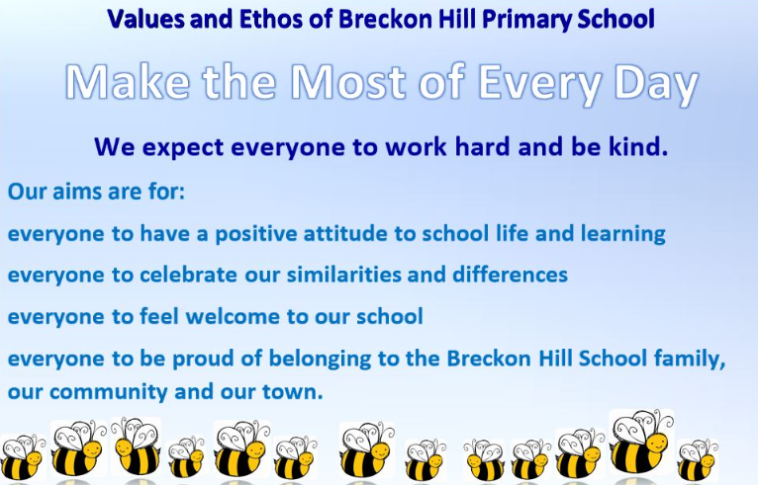
Breckon Hill is committed to meeting the needs of all pupils. We expect every child with SEND to receive a full and enriching education to enable them to achieve their potential and be ready and happy when they transition to their next school.
- How do we implement our vision?

- We see all teachers as teachers of SEND pupils.
- We seek advice from external experts to improve our offer, to ensure children’s needs are identified and to make certain our plans are making a positive difference for our pupils.
- We ensure that staff have the relevant training and support to ensure best practice at all times.
- We adapt the curriculum
- We allocate sufficient resources (including adults)
- We offer a holistic, sensory, emotion coaching approach to learning
Our Assistant Headteacher is also our SENDCo, she has frequent and open communication with staff and communicates this work to the whole school staff to ensure that the school community works together to implement plans and provide for children with SEND.
At every step of this process, we involve parents and families and build trusting and open relationships. It is important that we work as a team to ensure best outcomes for all pupils.
- Identification of need for all pupils who may have a SEND
SEND can include:
- Communication and interaction difficulties
- Cognition and learning challenges
- Social, emotional, and mental health needs
- Physical and sensory impairments
Identifying SEND in Young Children
Early identification of SEND is crucial for effective intervention. Look out for signs such as:
- Delayed speech or language skills
- Difficulty following instructions
- Challenges with motor skills
- Limited social interaction or play skills
- Sensory sensitivities (e.g., sound, touch, light)

Please contact our SENDCO and Assistant Headteacher if you have concerns. You may also speak with your child’s class teacher.

We aim to support pupils who may have a special need at the earliest opportunity to ensure every support is made available to pupils.
- The teacher will discuss their concerns directly with the SENDCo and the pupil’s parents/carers.
- The teacher will work with the SENDCo to initiate a school SEND support plan where parents will contribute to gain a full picture of the child and their needs and they will be informed their child has been placed on the SEND register and what this means.
- Teachers meet termly to discuss concerns with parents and careers
- It may be that the SENDCo will request support form the Inclusion Outreach Team from the LA.
- Where professionals and parents agree further support may be requested from agencies e.g. Educational Psychologist.
- It may be that a referral planning meeting is convened to initiate an Education Health Care Plan(EHCP)

- Curriculum
Curriculum provision is dependent on the needs of the pupil. Therefore, we do not prescribe to one specific teaching approach, as what works for one child may not work for another. This means that we draw on a variety of approaches, including traditional teaching methods for those pupils who are able to access subject specific learning. This allows a holistic approach centred on personalised learning with developmental learning intentions drawn from a variety of sources including (but not limited to) Development Matters, the National Curriculum Frameworks, the Autism Education Trust, the Engagement Model, Occupational Therapy programmes and Speech and Language interventions. While emphasis will be placed on the progression of all pupils and their academic achievement, this will be realised through a holistic approach to be delivered through the following three areas of development:
• academic curriculum;
• therapeutic input and offer; and
• social and emotional needs, communication and life skills
High levels of aspiration and achievement will be gained through a multi-sensory based personalised curriculum that is mindful of the uniqueness of each pupil’s learning difficulty covering the academic, therapeutic, social, emotional and mental health support. It also supports the physical development of pupils using a variety of movement programmes and drawing on the principles of sensory integration therapy.
Professionals will work together to develop the most appropriate curriculum and targets for pupils.
Pupils will be taught in contexts that expand their horizons and encourages them to demonstrate a range of strengths and skills underpinned by a range of suitable care and medical support and therapies. In this way, the curriculum is designed around the pupil rather than trying to fit the pupil into a given curriculum. This means that the teaching approach is fit for purpose.
Our aim is to ensure pupils will be prepared for the next stage in their learning journey with growing independence, strong social skills and the ability to get along with others, making friends and have good emotional well-being and feeling happy.
Provision:
• SEND support plan
• Small group teaching
• Personalised timetables as needed
• Sensory integration approach– timetabled and in response to presenting need advice from OT
• Symbol exchange
• Visual supports (incl. timetables, schedules, now and next)
• Objects of reference
• Makaton
• Communication supports
• Planned tasks about preparing for life
• Speech and language interventions
• Strategies to support independence
Central to the success of the curriculum is the integration of therapeutic approaches.
These include but are not limited to:
• Sensory diets
• Inclusive technology
• Proprioceptive massage
• Movement programmes/ Sensory Circuits
• Zones of Regulation
• Counselling/play therapy
- Support
The first point of contact is the class teacher. Teachers have overall responsibility for the welfare of the pupils in their class. They are supported in this role by the senior leadership team and a range of other professionals; we are committed to multi-agency working to ensure the needs of the whole child are met. Class teachers are supported by teaching assistants.
Where needed pupils have a care plan which identifies personal care needs, dietary requirements and administration of medication where appropriate.
The academy has access to advice and support from universal school nursing services where needed.
Professionals from other agencies such as occupational therapy and Speech and Language support visit the academy on a regular basis. These professionals support individual pupils offering advice and training to staff.
We work closely with the following agencies:
• Middlesbrough SEND team and Educational Psychology service
• Speech and Language
• CAMHS
• Occupational therapists
• Play therapist
• Social services
• Community nursing
• Harbour
• VI/HI services
• Pupils Looked After
• Ethnic minority team
Our Safeguarding, SEND and Attendance Officer, in partnership with our children and Family Team, provides support to parents, liaises between home/academy and monitors attendance.
Citizens Advice Bureau support can be accessed through school.
We have clear referral routes to external agencies which include: Social Care, CAMHS, Therapeutic support, Bennardo’s, Daisy Chain, Early Help. In addition, support and guidance from charitable organizations are signposted.
Home/school communication books are used regularly. A newsletter is sent home each month. We also use an App called Seesaw to celebrate the pupil’s success and support families with what is going on in school.
Pupil voice is encouraged in all areas and there are regular pupil council meetings. Pupils are informed about what bullying is and ways in which it can be dealt with. We log all incidents of bullying and although this is extremely rare, there is an option for restorative justice sessions. Pupils who are Looked After have access to all of the resources open to other pupils and in addition, regular review and monitoring meetings are held. We collect data on progress and attendance to ensure their performance is line with their peers.
- Accessibility
Breckon Hill is located in single site accommodation. The school has disabled toilets and washing facilities, and is fully wheelchair accessible. There is disabled parking within the car park and all visitors are able to enter two accessible entrances. Corridors are few, we have walkways that are wide and there are ramps. There is an outdoor play space. Within each classroom there are relevant resources and equipment to enable pupils to access the curriculum.
All staff and pupils who require special assistance during emergency evacuation are included in the academy Personal Emergency Evacuation Plan (PEEP). Routine fire and emergency evacuations exercises are held each term.
All visitors to the academy must report to the office and wear ID badges for the duration of their visit. Visitors working directly with pupils must produce a valid Disclosure and Barring certificate to office staff.
Where English is not the first language, the academy supports home/academy relations by utilising interpreters where appropriate.
ICT is used to help some of our pupils access the curriculum; there are interactive white boards, and iPads available.
There are a range of approaches to help develop communication throughout the academy; Symbol Exchange Communication System, Makaton (sign language).
- Parental involvement
Parents are always encouraged to support their child’s learning. Parents are invited events to meet staff and look at pupil’s work, as well as attending parent/teacher meetings and receiving a pupil report. We regularly invite parents to share a range of events and activities which include performances, awards and celebrations. Where a child has an EHC, parents are invited to the annual EHCP review meeting and are fully involved in updating EHC plans.
9. Staff training
All teachers have qualified teaching status. We have a comprehensive induction program for all staff. The majority of staff are first aid trained. Staff are also trained in positive handling, manual handling, safeguarding, PREVENT, GDPR and fire awareness. Staff training is ongoing to ensure we meet the educational needs of all our pupils and stay up to date with current research into teaching and learning.
As part of Legacy Learning Trust, staff share best practices from other schools as well as having access to our own central improvement team. Staff access training relevant to their roles and career stage, for example, middle leadership training or subject based training.
10. Activities outside of the school
Leaders are committed to providing opportunities for pupils to have equal access to an enriched and extended curriculum. A variety of activities are provided in school such as art, dance, music, cookery. Trips to local theatres, galleries, historic sites, parks, the farm etc. are part of the curriculum too. We also provide many opportunities to widen cultural experiences, such as visiting musical groups.
Our Children and Families team will keep parents up to date with suitable activities happening in the local area through the website and newsletters.
11. Transition
Transition arrangements are made on an individual basis for each pupil and in discussion with parents and professionals from previous provisions; this is to reduce pupil and parent anxiety.
Admission for pupils is usually in September into Reception but can occur at various stages of their education. For all, we ensure a comprehensive transition programme which may include visits from the staff and the leadership team to meet the new pupils, and regular visits by the new pupils to meet us in school.
Parents are welcomed to school. Likewise, when a pupil transitions to another provision, arrangements will be made to best suit the child and will be done collaboratively with parents and all professionals involved.
12. Policies and Guidance Documents
DfE – Supporting pupils at school with medical conditions (December 2015) DfE SEND Code of Practice (2014) DfE School Admissions Code (2014) Pupils & Families Bill (2013)
SEND Policy Admissions Policy
Attendance Policy Child Protection and Safeguarding Policy
Behaviour Policy
Equality Policy & Equality objectives
Accessibility Plan Health & Safety Policy Supporting pupils with medical needs Policy
Intimate Care policy
Pupil Premium policy
13. Further information
Middlesbrough council website is www.middlesbrough.gov.uk Middlesbrough Special Educational Needs Service (01642) 201831
Local Authority & Health Authority Middlesbrough Council Pupils with Disabilities Team 01642 579160
Middlesbrough LA SEN Team 01642 201381
Middlesbrough LA Parent Partnership Officer 01642 201872
The Cleveland Child Assessment Unit 01642 729972
Service for Pupils with Visual Impairment 01642 354353
Service for Pupils with Hearing Impairment 01642 354353
Middlesbrough Welfare Rights Service 01642 729242
Physiotherapy / Occupational Therapy Service 01642 774774
Speech & Language Therapy Service 01642 944488
Charities & support organisations In Control 01564 821650
Contact a Family 0808 808 3555 12 Whizz Kidz (info@whizz-kidz.org.uk) 020 7233 6600
Eston Salvation 01642 440834/01287 636192
Council for Disabled Pupils 0207 6088700
Parents 4 Change (Middlesbrough) 01642 774774
MAIN Project (Autism support) 01642 608012 SCOPE 0808 800 3333
Mencap 0808 808 1111
Disability Rights UK 0330 995 0404
Family Action 020 8519 2122 MIND (Mental Health) 020 8519 2122
Barnado’s (North East) 0191 240 4801
Forget Me Not (Teesside Hospice Child Bereavement) 01642 811063
I-Can (Pupils’s Communication) 020 7843 2544
Daisy Chain 01642 531248

