Keeping yourself safe
Whilst on site, you must always remain professional. Please be aware that you may be escorted or supervised throughout your visit.
Always be aware of how you speak to a pupil – they may interpret jokes or compliments differently.
You should avoid being alone with a pupil; however, if your duties require you to be alone with a pupil, always ensure that a desk is between you, the door is open, or you can be seen so that you are visible to others.
If a pupil behaves inappropriately, you must tell the DESL, or headteacher or the deputy headteacher.
You must never share contact details with a pupil or arrange to meet them outside of school hours.
Pupils should not be contacted through social media and you should not discuss the school, its teachers or its pupils across such platforms.
Taking photographs or recording videos is not permitted unless consent has been granted by the headteacher for the relevant school activity.

Useful contacts

The DSL is Helen Chapman, Assistant Headteacher.

If you have any questions or comments about the safeguarding of pupils, you can contact the DSL using the details below.

Below is a list of useful contacts .
Headteacher – Joanne Smith Deputy DSL
Deputy Headteacher – Dawn Camp Deputy DSL
Carol Price Admissions and Attendance Officer – Deputy DSL

Chair of governors – Ian Mawson
Safeguarding governor – Ian Mawson

Breckon Hill Primary School

Child protection and safeguarding guide for visitors

We are committed to protecting our pupils from harm and safeguarding their welfare
To ensure this, we ask that all staff, volunteers and visitors share this commitment too.
This leaflet contains information about our expectations while you are visiting us. If you have questions about these arrangements, please speak to any of the named contacts included on the reverse side of this leaflet.
Please be advised that this leaflet covers topics that may be sensitive in natur

Visitor procedures
All visitors, including trainee teachers, volunteers, parents, and those on work experience, must:
- Immediately report to the school office on arrival.
- Provide their details to the relevant staff, including their name, the purpose of the visit, the name of the pupil the visit affects and/or the name of the staff member who arranged the visit.
- Sign in using the visitors’ book.
- Display the Visitor ID badge provided at all times whilst on the school premises.
- Return the ID badge to the school office before departure.
- Sign out upon departure.

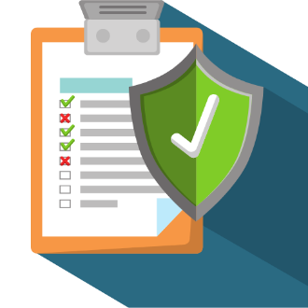

g is a list of y
Reporting concerns
You must inform the school’s designated safeguarding lead (DSL) if you are worried about:
- Something a pupil says.
- Marks or bruising on a pupil.
- A pupil’s behaviour, or changes to their behaviour.
Our DSL is Helen Chapman.
If a pupil discloses that they are being harmed you must:
- React calmly.
- Listen carefully.
- Not promise confidentiality; explain that you may need to tell somebody if the pupil’s safety is at risk.
- Not question the pupil further – this should be done by somebody who is trained to investigate.
- Reassure the pupil that they have done the right thing.
- Take a record of what the pupil has said, including the date, time and how and when the information was received. This information must be passed to the DSL immediately.

Should you have concerns about the conduct of a member of staff following an observation or disclosure, you must immediately inform the headteacher or, in their absence or if the concern regards them, the deputy headteacher.

