Breckon Hill Primary School

Breckon Hill Road

Middlesbrough

TS4 2DS

Tel: 01642 243044

Headteacher: Mrs J Smith

e-mail: contact@breckonhillprimary.co.uk
website: www.breckonhillprimary.co.uk
E- SAFETY
Dear Parents and Children
Please find a family user agreement that you may find useful when talking your child about keeping safe online.
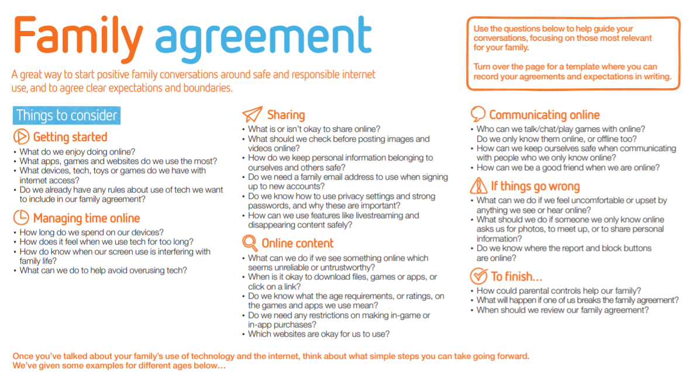
Developing excellent practice in e-safety is always part of our work. Your child’s will be talking with the children so that they understand that the rules of keeping as safe as possible online, our website has links to resources that support both parents and teachers in educating children about using the internet safely: http://www.breckonhillprimary.co.uk/

Yours sincerely

Mrs Smith

