Breckon Hill Primary School
Policy for Behaviour

May 2021

Our Vision

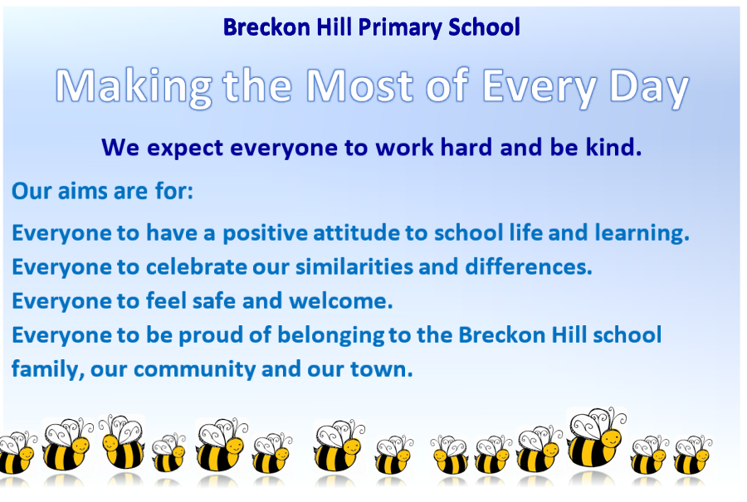

Behaviour Policy Statement
Breckon Hill Governors and leadership team promote positive behaviour. We believe that all children are ‘gifted and talented’ in their own unique ways and capable of being successful in their learning. We aim to ensure our school offers a safe, orderly and respectful community in which all children’s and young people’s talents can be developed and used to the full.
Relationships are at the centre of our work. At the heart of our school is the high quality and enriching relationships that exist between our children, young people and our staff. The senior leaders in school work to promote positive working relationships and support pupils who find making good choices difficult.
Our emphasis is on recognising and celebrating effort and success so that all members of the school community feel valued. We teach pupils to take responsibility for their own actions and to recognise the consequences of their choices. We believe it is essential that every child in our school is given every opportunity to build up their own self-esteem to ensure they can feel proud of themselves within the school community.

Aims
At Breckon Hill governors, senior leaders, teachers and all staff believe that good behaviour is the key to a good education. We work to create a learning environment where everyone feels valued, secure and motivated to learn. We firmly believe that every member of our school community has a responsibility to teach children socially acceptable behavior to ensure all children succeed in the wider community.
- We aim to promote high standards by modelling positive behaviour at all times.
- We aim to encourage high standards of work and behaviour, emphasising praise and positive reinforcement.
- We aim to ensure that all adults and children treat each other with mutual respect and consideration.
- We aim to ensure teachers and staff are well-supported and look to source research-based findings into children’s behaviour to enable all children to learn in a calm and happy environment.
At Breckon Hill Primary School we will highlight and reward achievements, good behaviour, attendance and hard work in the following ways:
- Star of the Week
- Busy Bee Worker
- Homework Certificate
- Lunchtime Leader Award for showing respect and good manners in the dinner hall
- Badges to wear with pride – you first, me last; science; handwriting; singing etc.
- Medals linked to The Schools Games values – Respect, honesty, fair play etc
- The cup of kindness
- Stickers and stamps
- Positive comments in books or verbal praise in class
- Children showing their work to Subject Leaders and SLT
- House points to encourage teamwork
At Breckon Hill Primary School we only have two school rules:
- Be Kind
- Work Hard
We believe these two rules are the foundation of positive behaviour and attitudes in our school environment, they ensure our school vision succeeds.

Rights and Responsibilities
We instill the teachings of Rights Respecting Schools and everyone within our school community have rights and responsibilities to ensure that school is a safe place in which to learn, work and play.
- Children have the right to learn, work and play in a friendly, safe and helpful school and the responsibility to help others learn work and play in a safe and friendly environment.
- Teachers and staff have the right to teach and work in a friendly, safe and caring school, which are supported by the Leadership Team. The community, the teachers and staff have the responsibility to foster a positive learning community.
- Parents and Carers have the right to feel welcome and to know that our children learn, work and play in a friendly, safe and helpful school and have a responsibility to support the school to make sure their children follow rules to foster a safe and friendly learning community.
Roles and responsibilities
It is the responsibility of the Governing Body to establish a policy and procedure for Behaviour and Discipline and to monitor the effects of the procedure.
It is the responsibility of the Headteacher to:
- Encourage and foster acceptable standards of behaviour, good personal relationships and a respect for the individual.
- Address promptly any breaches of good conduct and behaviour, using informal procedures where possible but implementing formal procedures where necessary.
It is the responsibility of all staff to familiarise themselves and support, with this policy and procedure in accordance with relevant professional standards. In particular, staff should:
- ensure that pupils enter and leave the classroom in an orderly manner;
- display good classroom management;
- mark and return work promptly and regularly;
- be courteous and polite to pupils;
- praise, encourage and reward pupils wherever possible and consequently encourage appropriate behaviour;
- make it obvious that each pupil is of equal importance and that praise, rewards and sanctions are used equitably; and seek further help and guidance from other members of staff and regard this as an appropriate strategy rather than an admission of failure.
- recognise that through their own behaviour and manner they will demonstrate and encourage high standards.
It is the responsibility of pupils to develop positive relationships in the school and demonstrate acceptable standards of behaviour, good personal relationships and a respect for the individual.
It is the responsibility of parents/carers to support the school in encouraging and nurturing in their children, acceptable standards of behaviour, good personal relationships and a respect for the individual.
RELATIONSHIPS
Developing positive relationships with pupils is key to creating a classroom environment and ethos that is calming, inclusive and makes everyone feel valued. A simple, positive greeting to each child individually when they arrive is crucial to setting the right ambience for the day ahead.
Staff need to encourage pupils to develop their own self-help strategies that enable them to re-establish a positive mind set when faced with a challenging situation. Throughout their interactions with pupils in school, staff should demonstrate a ‘deliberate botherdness’ in which they promote a true interest in each child and their situation.
Two simple rules of:
- Be Kind
- Work Hard
need to be shared with pupils at the start of the school year and throughout, in order to ensure a positive climate for learning remains established.

MONITORING AND REVIEW
The Headteacher monitors the effectiveness of this policy on a regular basis. She also reports to the governing body on the effectiveness of the policy and, if necessary, makes recommendations for further improvements.

Why Positive Behaviour Management?
In the world around them, children see many different examples of how people behave. We have a responsibility to help children understand that they have choices about how to behave and help them develop the strategies to make appropriate choices.
Our aim is to create an environment where children feel valued, safe and motivated to learn. We believe that good behaviour and discipline are the foundation of all learning, and without a calm, orderly atmosphere, effective teaching and learning cannot take place.
We believe that children respond best to praise and encouragement. We must try to find every opportunity to praise children when they are showing appropriate behaviour. Children learn by example. Teachers and parents have a responsibility in setting a good example as well as ensuring that the rules are followed.
Staff work to promote positive behaviour at every opportunity. School assemblies provide a focal point for talking about and reinforcing aspects of school ethos. Staff hold regular key stage assemblies to revise positive behaviour. Children are rewarded with Busy Bees, House Points, and Pupil of the Week, The Cup of kindness, prizes, stickers, certificates, privileges and treats. At the end of every term, awards are given to children who have demonstrated a kind, respectful and hardworking attitude to school. Class teachers should regularly review the behaviour policy with the children to ensure that everyone is clear about our expectations.
The school acknowledges all the efforts and achievements of children, both in and out of the school.
- We expect children to be attentive in lessons.
- We expect children to try their best in all activities. If they do not do so, we may ask them to repeat a task or activity.
- If a child is disruptive in class, the teacher will verbally give them a reminder about suitable behaviour. If a child misbehaves again, then they will receive another verbal reminder. If the behaviour continues, they will be asked to work in another area of the classroom or another area. On the third reminder, they will be asked to remain behind after class and as consequence miss the next break time to complete tasks and reflect on their behaviour. If disruptive behaviour continues, then a member of the senior leadership team will step in to support and when necessary remove the child from the classroom to another area. One child should not be allowed to negatively impact the learning environment for the rest of the class.
- The safety of the children is paramount in all situations. If a child's behaviour endangers the safety of others, the class teacher will stop the activity and prevent the child from taking part for the rest of that session. A member of the senior leadership team will be asked to support.
- If a child threatens or hurts another child, the class teacher will record the incident and consequences will be discussed with parents or carers.
- If a child repeatedly acts in a way that disrupts or upsets others, the school will contact the child's parents or carers and seek an appointment in order to discuss the situation, with a view to improving the behaviour of the child, with the full co-operation of the parents.
- The class teacher will discuss the rules with each class. In addition to the school rules, each class also has its own Rights Respecting Class Charter. The plans are agreed by the children and displayed on the wall of the classroom.
- There is also a whole school behaviour chart, which describes acceptable playtime and lunchtime behaviour – this is displayed in the classroom. In this way, every child in the school knows the standard of behaviour that we expect in our school.
- The school does not tolerate bullying of any kind. If we discover that an act of bullying or intimidation has taken place, we act immediately to stop any further occurrences of such behaviour. While it is very difficult to eradicate bullying, we do everything in our power to ensure that all children attend school free from fear of any kind of hurt from others.

Anti-BULLYING
For the purpose of this policy, “bullying” is defined as persistent behaviour by an individual or group with the intention of verbally, physically, or emotionally harming another person or group. Bullying is generally characterised by:
- Repetition: Incidents are not one-offs; they are frequent and happen over a period of time.
- Intent: The perpetrator(s) means to cause verbal, physical or emotional harm; it is not accidental.
- Targeting: Bullying is generally targeted at a specific individual or group.
- Power imbalance: Whether real or perceived, bullying is generally based on unequal power relations.
Everyone at Breckon Hill Primary School has the right to feel welcome, secure and
happy. Only if this is the case will all our children be able to achieve their full potential. Bullying of any kind prevents this from happening. It is therefore everyone’s responsibility, staff and children, to prevent bullying from taking place.
If we become aware of an alleged bullying incident, we will investigate the incident, talk to the victim, talk to the children alleged of bullying and talk to any witnesses. If after we have investigated the incident it is decided that bullying has taken place, we will inform the parents of all involved and work with children to resolve issues.
Parents are to be reminded regularly to inform their children that they must tell someone should they ever feel they are being bullied and if parents learn that their child is being bullied they are to inform the school immediately.

ALLEGATIONS OF PEER ON PEER ABUSE
Sexual harassment refers to unwanted conduct of a sexual nature that occurs online or offline. Sexual harassment violates a pupil’s dignity and makes them feel intimidated, degraded or humiliated, and can create a hostile, sexualised or offensive environment. If left unchallenged, sexual harassment can create an atmosphere that normalises inappropriate behaviour and may lead to sexual violence.
Sexual harassment includes:
- Sexual comments.
- Sexual “jokes” and taunting.
- Physical behaviour, such as deliberately brushing against another pupil.
- Online sexual harassment, including non-consensual sharing of images and videos and consensual sharing of sexual images and videos (often known as sexting), inappropriate comments on social media, exploitation, coercion and threats – online sexual harassment may be isolated or part of a wider pattern.

In order to prevent peer-on-peer abuse and address the wider societal factors that can
influence behaviour, the school will educate pupils about abuse, its forms and the importance of discussing any concerns and respecting others through the curriculum,
assemblies and PSHE lessons.
The school will also ensure that pupils are taught about safeguarding, including online
safety, as part of a broad and balanced curriculum in PSHE lessons, RSE and group
sessions. Such content will be age and stage of development specific, and tackle
issues such as the following:
- Healthy relationships
- Respectful behaviour
- Gender roles, stereotyping and equality
- Body confidence and self-esteem
- Prejudiced behaviour

The Use of Reasonable Force
In order to maintain the safety and welfare of our pupils, it may sometimes be necessary to use reasonable force, as permitted by law. This is only to be used when all possible options for giving the child time/space to regain self-control have been exhausted.
Force will never be used as a punishment.

Fixed-Term and Permanent Exclusions
We do not wish to exclude any child from school, but sometimes this may be necessary. The school has therefore adopted the standard national list of reasons for exclusion, and the standard guidance, Statutory Guidance on School Exclusions (September 2012). We refer to this guidance in any decision to exclude a child from school.
Only the Headteacher has the power to exclude a child from school. They may exclude a child for one or more fixed periods, for up to 45 days in any one school year. In extreme and exceptional circumstances, the Headteacher may exclude a child permanently. It is also possible for Headteacher to convert a fixed-term exclusion into a permanent exclusion, if the circumstances warrant this.
If a child has received a fixed-term exclusion, the parent and child will have to attend a re-integration meeting to discuss the unacceptable behavior on the first day back to school. This will involve setting new targets and ensuring that the undesirable behavior does not occur again.

