 | Theme 1 | Theme 2 | Theme 3 and 4 |  | Theme 5 and 6
Driver | History/Geography | History | Cross curricular |  | History/ Geography
Theme Title | Who were the Maya and where did they live? | How did WW2 impact people’s lives? | Who inspires us and why? |  | What was special about the Ancient Egyptians?
Why this topic and why now?  (Rationale) | To consider with ‘The Day of the Dead’ celebration. To develop the children’s understanding of other cultures and the history of another country. | To consider the importance of Remembrance day. Developing chronological knowledge of world history from what they have learned previously. Understand the impact on the UK and local area. | To learn about various people who are well-known for different things to inspire children. To motivate children for choices they will make heading towards transition and secondary school. |  | To develop children’s understanding of early civilizations, building on chronologically from Lower Key Stage 2 and build on historical enquiry skills.
Enrichment |  | VE Day Celebration | Visits from Local People  Residential |  | Dorman Museum | Bell Boating  Sports week
Remembering experience | Parent share | Quiz | Exhibition |  | Ancient Egypt Hancock Museum | Y6 Assembly
Science | identify and name the main parts of the human circulatory system, and describe the functions of the heart, blood vessels and blood  recognise the impact of diet, exercise, drugs and lifestyle on the way their bodies function  describe the ways in which nutrients and water are transported within animals, including humans. | associate the brightness of a lamp or the volume of a buzzer with the number and voltage of cells used in the circuit  compare and give reasons for variations in how components function, including the brightness of bulbs, the loudness of buzzers and the on/off position of switches  use recognised symbols when representing a simple circuit in a diagram.  describe how living things are classified into broad groups according to common observable characteristics and based on similarities and differences, including micro-organisms, plants and animals  give reasons for classifying plants and animals based on specific characteristics. | recognise that living things have changed over time and that fossils provide information about living things that inhabited the Earth millions of years ago  recognise that living things produce offspring of the same kind, but normally offspring vary and are not identical to their parents  identify how animals and plants are adapted to suit their environment in different ways and that adaptation may lead to evolution. |  | recognise that light appears to travel in straight lines  use the idea that light travels in straight lines to explain that objects are seen because they give out or reflect light into the eye  explain that we see things because light travels from light sources to our eyes or from light sources to objects and then to our eyes  use the idea that light travels in straight lines to explain why shadows have the same shape as the objects that cast them.
Geography | A study of the Mayans, where were they located, identify climate, physical and human features. We will journey the changes of settlements in Mexico through time.  Recap identify significance of latitude longitude hemispheres and time zones – Greenwich.  Place knowledge – similarities and differences through the study of human and physical geography of a region in the UK and Mexico.  Identifying the significance of latitude longitude equator hemispheres and time zones – night and day (importance of sun to ancient Mayan population) | Identify and locate the countries involved in WWII and how the land use changed during the war. To understand how Middlesbrough was affected during world war and how the area managed these impacts. | Locate significant cities and towns associated with the life of Nelson Mandela to understand his journey to freedom.  Create a persuasive leaflet about South Africa’s landscape, significant physical and human features key to tourism (mountain ranges, rivers, cities) and the wildlife unique to the country. |  | A study of Egypt, where it is in the world, identify physical and human features.  Create a fact file explaining how Egypt used land for settlements to survive droughts, the use of farming to support their communities, how Egypt have formed trade links with other counties to distribute their resources and improve the economy.
History | - a non-European society that provides contrasts with British history Mayan civilization c. AD 900  Mayans | - a study of an aspect or theme in British history that extends pupils’ chronological knowledge beyond 1066  WW2  Hollis | Check study of people |  | - the achievements of the earliest civilizations – an overview of where and when the first civilizations appeared and a depth study of one of the following: Ancient Sumer; The Indus Valley; Ancient Egypt; The Shang Dynasty of Ancient China  Ancient Egyptians
ART  Core Experiences/skills to be taught  Artists  Designers  Craft makers | Drawing  Painting  3D/Textiles | Drawing | Drawing  Painting  Printing  Sketch books |  | Drawing  Painting  Knowledge  3D/Textiles
 | Maya sculpture  https://www.incredibleart.org/lessons/elem/loganmayan.html  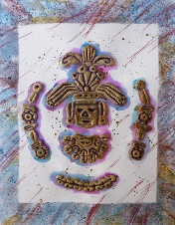 | Henry Moore- Shelter drawings  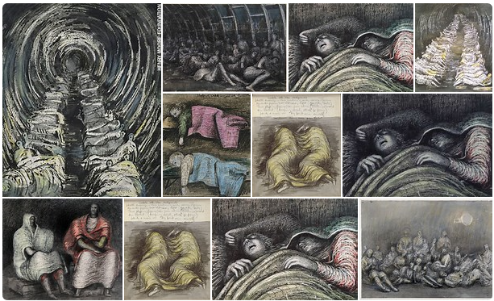 | Banksy  https://www.bing.com/images/search?q=Stencil+Art+Kids&FORM=RESTAB  Stencil art  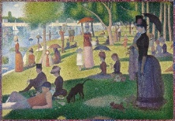  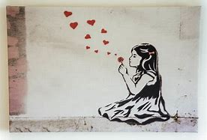  Georges Seurat  Pointillism |  | Ancient Egypt  https://www.britishmuseum.org/learn/schools/ages-7-11/ancient-egypt  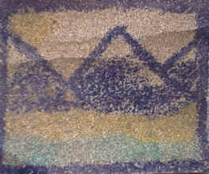
Design and Technology | Clay mask,  Make Mexican food  (Geography/History Link) | Design and make an Anderson Shelter | Development of the Hoover  Design a healthy meal. |  | Research, plan and design a Shaduf  (History Link)
Computing | - Design, write and debug programs that accomplish specific goals, including controlling or simulating physical systems; solve problems by decomposing them into smaller parts.  - Use sequence, selection and repetition in programs; work with variables and various forms of input and output.  - Use logical reasoning to explain how some simple algorithms work and to detect and correct errors in algorithms and programs  - Select, use and combine a variety of software (including internet services) on a range of digital devices to design and create a range of programs, systems and content that accomplish given goals, including collecting, analysing, evaluating and presenting data and information.  - Understand computer networks, including the Internet; how they can provide multiple services, such as the World Wide Web; and the opportunities they offer for communication and collaboration  - Use search technologies effectively, appreciate how results are selected and ranked, and be discerning in evaluating digital content  - Use technology safely, respectfully and responsibly; recognise acceptable/unacceptable behaviour; identify a range of ways to report concerns about content and contact  - Select, use and combine a variety of software (including internet services) on a range of digital devices to design and create a range of programs, systems and content that accomplish given goals, including collecting, analysing, evaluating and presenting data and information.  - understand computer networks including the internet; how they can provide multiple services, such as the world wide web; and the opportunities they offer for communication and collaboration  - use technology safely, respectfully and responsibly; recognise acceptable/unacceptable behaviour; identify a range of ways to report concerns about content and contact.  - design, write and debug programs that accomplish specific goals, including controlling or simulating physical systems; solve problems by decomposing them into smaller parts  - use sequence, selection, and repetition in programs; work with variables and various forms of input and output  - use logical reasoning to explain how some simple algorithms work and to detect and correct errors in algorithms and programs  - Design, write and debug programs that accomplish specific goals, including controlling or simulating physical systems; solve problems by decomposing them into smaller parts.  - Use sequence, selection and repetition in programs; work with variables and various forms of input and output  - Use logical reasoning to explain how some simple algorithms work and to detect and correct errors in algorithms and programs  - Select, use and combine a variety of software (including internet services) on a range of digital devices to design and create a range of programs, systems and content that accomplish given goals, including collecting, analysing, evaluating and presenting data and information.  - Select, use and combine a variety of software (including internet services) on a range of digital devices to design and create a range of programs, systems and content that accomplish given goals, including collecting, analysing, evaluating and presenting data and information
 | Purple Mash 6.1: Coding | Purple Mash 6.2: Online Safety | Purple Mash 6.4: Blogging  Purple Mash 6.5: Text Adventures |  |  | Purple Mash 6.7: Quizzing
Music | - play and perform in solo and ensemble contexts, using their voices and playing musical instruments with increasing accuracy, fluency, control and expression  - improvise and compose music for a range of purposes using the inter-related dimensions of music  - listen with attention to detail and recall sounds with increasing aural memory  - use and understand staff and other musical notations  - appreciate and understand a wide range of high-quality live and recorded music drawn from different traditions and from great composers and musicians  - develop an understanding of the history of music.
 | Charanga: Happy | Charanga: Classroom Jazz 2 | Study the music of Beethoven  Charanga: Music and Me |  |  | Charanga: You’ve Got a Friend
MFL | - listen attentively to spoken language and show understanding by joining in and responding  - explore the patterns and sounds of language through songs and rhymes and link the spelling, sound and meaning of words  - engage in conversations; ask and answer questions; express opinions and respond to those of others; seek clarification and help  - speak in sentences, using familiar vocabulary, phrases and basic language structures  - develop accurate pronunciation and intonation so that others understand when they are reading aloud or using familiar words and phrases  - present ideas and information orally to a range of audiences  - read carefully and show understanding of words, phrases and simple writing  - appreciate stories, songs, poems and rhymes in the language  - broaden their vocabulary and develop their ability to understand new words that are introduced into familiar written material, including through using a dictionary  - write phrases from memory, and adapt these to create new sentences, to express ideas clearly  - describe people, places, things and actions orally and in writing
 | Rigolo Unit 7: Le week-end (The Weekend) | Rigolo Unit 8: Les vetements (Clothes) | Rigolo Unit 9: Ma journee (Daily Routine)  Rigolo Unit 10: Les transports (Transport) |  | Rigolo Unit 11: Le sport (Sport) | Rigolo Unit 12: On va faire la fete
PE | - use running, jumping, throwing and catching in isolation and in combination  - play competitive games, modified where appropriate [for example, badminton, basketball, cricket, football, hockey, netball, rounder and tennis], and apply basic principles suitable for attacking and defending  - develop flexibility, strength, technique, control and balance [for example, through athletics and gymnastics]  - perform dances using a range of movement patterns  - take part in outdoor and adventurous activity challenges both individually and within a team  - compare their performances with previous ones and demonstrate improvement to achieve their personal best
 | Tag Rugby  Golf | Boot Camp  Indoor Athletics | Table Tennis  Netball | Basketball  Dance | Cricket  Badminton | Athletics  Dodgeball
PHSE | FPA Changes at Puberty  FPA Periods (menstruation)  (Girls only)  FPA Wet Dreams and Masturbation  (Boys only)  September International Day of Democracy (Pupil Parliament Vote)  October Harvest Festival (Foodbank Hampers) | British Values: November Parliament Week and cover all 5 British values.  - Local MP and Ward council to visit.  - November Remembrance Day  November Inter Faith Week  November Anti-bullying Week | FPA Friendships and Pressure  January World Religion Day  February E-Safety Week  February Children’s Mental Health Week | FPA Identity and Prejudice  FPA Equality and The Law  March World Water Day  March Money Sense Week | FPA Keeping Safe – Online Images  Local PCSO Officer to visit the children  FPA Keeping Safe – Safe and Unsafe Touch | FPA Getting Help  BBC Secondary School Transition Films and activities (workbook supported)  Legal and illegal Drugs  Basic First Aid Training British Heart Foundation  June Refugee Week  July Sports Week
RE | R.E Today Services  Key Question – Unit 2.7: What matters most to Christians and to Humanists? | R.E Today Services  Key Question – Unit 2.8: What difference does it make to believe in Ahimsa (harmlessness), Grace (the generosity of God), and Ummah (community)? | R.E Today Services  Key Question – Unit 2.5: Is it better to express your religion in arts and architecture or in charity and generosity? |  |  | R.E Today Services  Key Question – Unit 2.3: What do religions say to us when life gets hard?

