 | Theme 1 | Theme 2 | Theme 3 | Theme 4 | Theme 5 | Theme 6
Driver | History | Science | Geography  Science | Geography | History | Geography
Theme Title | What did we learn from the Romans? | How does climate influence our world? | Where in the world is Brazil? | Why are rivers important? | Who was involved in the struggle for the Kingdom of England?
Why this topic and why now?  (Rationale) | Developing chronological knowledge started in Year 3 and beginning to understand how historical knowledge is built up through a range of sources. | Building on KS1 and Y3 knowledge of the human body and beginning to learn about the important systems within.  Moving on from identifying animals and beginning to think about how wider environments influence animal populations and food chains. | Children learn about sound and how it travels through the development of scientific enquiry skills taught in KS1 and Y3. | Develop understanding of physical geographical features by identifying key topographical features. Focusing on a local river to build on fieldwork and map skills from Y3. Knowledge is then extended to consider wider implications of flood defences and climate change around the world. | Continue developing chronological knowledge and creating a narrative from the end of the Romans through the Viking and Anglo Saxon struggle for the Kingdom of England.
Enrichment | Arbeia Roman Fort | Theatre | Visiting Scientist | River Tees Visit/Barrage Trip /Environment Agency Visitor | Kirkleatham?  Performance | Sports’ week
Remembering Experience | Quiz |  | Parent work share |  | Museum in the Classroom
Science | The digestive system in humans  Teeth in humans and their simple functions  of food chains, identifying producers, predators and prey.  Living things can be grouped in a variety of ways  Classification keys to help group, identify and name a variety of living things in their local and wider Environment  Environments can change and that this can sometimes pose dangers to living things. |  | Sound | States of Matter | Electricity
Geography | The Roman Empire and its impact on Britain  Romans | Biomes  From farm to fork  https://archive.foodafactoflife.org.uk/Activity.aspx?siteId=15&sectionId=66&contentId=177 | Brazil  The physical and human features of Brazil  Natural resources and trade links | Rivers  The water cycle.  Learning about rivers around the world.  The River Tees and its importance for us.  The importance of the Tees barrage in response to flooding. | The Viking and Anglo-Saxon struggle for the Kingdom of England to the time of Edward the Confessor.
History |  |  | Slave Trade
Core Experiences/  Skills to be taught | Knowledge  Sketchbooks | Drawing  Painting | Drawing  Painting  3D/Textiles  Sketch books | Drawing  Painting  Sketch books  Use of IT | Drawing  Painting  Use of IT  3D/Textiles
Artists  Designers  Craft makers | A Roman Triumph  https://www.nationalgallery. org.uk /media/31342/teachers-notes-rubens-2016.pdf  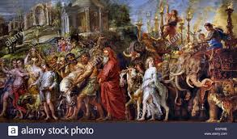 | Pop Art  Andy Warhol  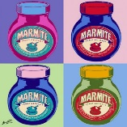  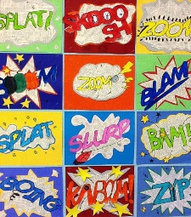  Roy Lichtenstein | Fauvism  Continuing the Narrative: Take a Journey Through a Painting  The Story of Joseph Biagio d'Antonio  RE LINK  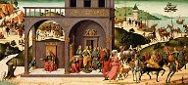 | 'Men of the Docks'  George Bellows  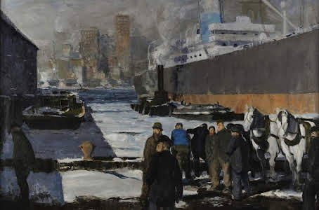  https://www.nationalgallery.org.uk /media/31343/national-gallery-teachers-notes-2018_9.pdf  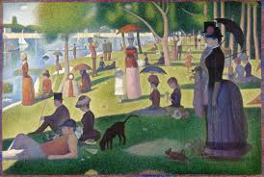  Seurat The Bathers | Bayeux tapestry  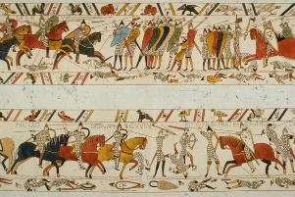
DT | Make a trebuchet, decorate with family crest. Class competition using ping pong balls.  History Link |  | 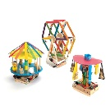  https://www.tts-group.co.uk/make-your-own-fairgrounds-dt-class-kit/1000370.html?cgid=Primary-D--T-Project_Kits |  | Design an Alarm System for a chosen purpose (Science Link)
Computing | - understand computer networks, including the internet; how they can provide multiple services, such as the World Wide Web, and the opportunities they offer for communication and collaboration.  - use search technologies effectively, appreciate how results are selected and ranked, and be discerning in evaluating digital content.  - design, write and debug programs that accomplish specific goals, including controlling or simulating physical systems; solve problems by decomposing them into smaller parts.  - use search technologies effectively, appreciate how results are selected and ranked, and be discerning in evaluating digital content.  - select, use and combine a variety of software (including internet services) on a range of digital devices to design and create a range of programs, systems and content that accomplish given goals, including collecting, analysing, evaluating and presenting data and information.  - use sequence, selection, and repetition in programs; work with variables and various forms of input and output.  - select, use and combine a variety of software (including internet services) on a range of digital devices to design and create a range of programs, systems and content that accomplish given goals, including collecting, analysing, evaluating and presenting data and information.  - use search technologies effectively, appreciate how results are selected and ranked, and be discerning in evaluating digital content.  - use sequence, selection, and repetition in programs; work with variables and various forms of input and output.  - design, write and debug programs that accomplish specific goals, including controlling or simulating physical systems; solve problems by decomposing them into smaller parts  - use sequence, selection, and repetition in programs; work with variables and various forms of input and output  - use logical reasoning to explain how some simple algorithms work and to detect and correct errors in algorithms and programs.
 | Purple Mash Unit 4.2: E-Safety | Purple Mash Unit 4.1: Coding | Purple Mash Unit 4.4: Writing for Different Audiences  Purple Mash 4.6: Animation | Purple Mash Unit 4.3: Spreadsheets | Purple Mash Unit 4.7: Effective Searching  Purple Mash 4.5: Logo | Purple Mash 4.8: Hardware
Music | - play and perform in solo and ensemble contexts, using their voices and playing musical instruments with increasing accuracy, fluency, control and expression  - improvise and compose music for a range of purposes using the inter-related dimensions of music  - listen with attention to detail and recall sounds with increasing aural memory  - use and understand staff and other musical notations  - appreciate and understand a wide range of high-quality live and recorded music drawn from different traditions and from great composers and musicians  - develop an understanding of the history of music.
 | Charanga: Mamma Mia | Charanga: Stop! | Charanga: Lean on Me | Charanga: Blackbird | Songs for Viking play | Charanga: Reflect, Replay, Rewind
MFL | - listen attentively to spoken language and show understanding by joining in and responding  - explore the patterns and sounds of language through songs and rhymes and link the spelling, sound and meaning of words  - engage in conversations; ask and answer questions; express opinions and respond to those of others; seek clarification and help  - speak in sentences, using familiar vocabulary, phrases and basic language structures  - develop accurate pronunciation and intonation so that others understand when they are reading aloud or using familiar words and phrases  - present ideas and information orally to a range of audiences  - read carefully and show understanding of words, phrases and simple writing  - appreciate stories, songs, poems and rhymes in the language  - broaden their vocabulary and develop their ability to understand new words that are introduced into familiar written material, including through using a dictionary  - write phrases from memory, and adapt these to create new sentences, to express ideas clearly  - describe people, places, things and actions orally and in writing
 | Rigolo Unit 7: Encore! (People and places) | Rigolo Unit 8: Quelle heure est-il? (Time) | Rigolo Unit 9: Les fêtes (Festivals) | Rigolo Unit 10: Où vas-tu? (Where are you going?) | Rigolo Unit 11: On mange! (Eating) | Rigolo Unit 12: Le cirque (Different languages)
PE | - use running, jumping, throwing and catching in isolation and in combination  - play competitive games, modified where appropriate [for example, badminton, basketball, cricket, football, hockey, netball, rounder and tennis], and apply basic principles suitable for attacking and defending  - develop flexibility, strength, technique, control and balance [for example, through athletics and gymnastics]  - perform dances using a range of movement patterns  - take part in outdoor and adventurous activity challenges both individually and within a team  - compare their performances with previous ones and demonstrate improvement to achieve their personal best
 | Tag Rugby  Gymnastics | Indoor Athletics  Dance | Fitness  Dodgeball | Tennis  Football | Orienteering  Rounders | Athletics  Cricket
PHSE | Online technology safety: Photos of myself online. | Online technology safety: Taking care online | Relationships: What makes a good friend.  Relationships: Getting on with family | Keeping Safe: Good and Bad Touch (NSPCC) | Gender Stereotypes: Jobs | Gender Stereotypes: Mothers and Fathers.
RE | Why is Jesus inspiring to some people? | Why do some people think life is a journey? | What can we learn from religions about deciding what is right and wrong? | Why are festivals important to religious communities? |  | What does it mean to be a Hindu in Britain today?

