 | Theme 1 | Theme 2 | Theme 3 | Theme 4 | Theme 5 | Theme 6
Driver | Geography and History |  | Geography and History |  | Science and Art
Theme Title | What was the seaside like 100 years ago? | Who is Captain Cook, what did he do and where did he go? | Who is Samuel Pepys? | Where is our town in our country and where is our country in the UK? | What do we need to grow and be healthy? |  | What is a micro-organism?
Why this topic and why now?  (Rationale) | Children are building on their knowledge from Y1 Summer 2 of simple fieldwork and observational skills to study the geography of their school and the key human and physical features of its surrounding environment we are going to explore the physical and human features of the seaside. We have chosen to start with this topic to build on their most recent topic from Y1. | Captain James Cook is a significant person from history who is from our local area. The Geography in this topic builds on from the previous topic of the Seaside looking at the 7 continents and 5 oceans. Children are building on their knowledge of changes over time ‘Now and Then’ , they are asked the question, ‘how do we know?’ when looking for evidence. | Children are developing skills to look further into the past and see how not only significant people can contribute to change but also significant events. Learning how the devastation of the Great Fire of London meant how houses where no longer made from wood and instead brick. | Children continue to develop their knowledge of their locality.  My home, school, my town, my countryside, my capital city topic. We are going to explore the four countries and their capital cities in the UK.  This also follows the previous topic of The Great Fire of London to build on their knowledge of what London was like then and what it is like now. | Children are building on their knowledge from Y1’s Paws, claws and whiskers topic. We are learning about and describing the basic needs of animals including humans for survival. |  | Children are building on their knowledge from the previous topic (Animals including humans) and now exploring in more detail their habitats.  We have chosen this topic now for the seasonal benefits to see a range of plants/ habitats for micro-organisms.
Enrichment | Saltburn Visit/Theatre Visit |  | Fire station Visit |  | Saltholme Visit  Sports’ Week
Remembering Experience | Museum in the classroom  Performance for Parents |  | Quiz |  | Take One Picture exhibition  Parent showcase
Science | Plants – changes over time (stand alone topic)  - observe and describe how seeds and bulbs grow into mature plants  - find out and describe how plants need water, light and a suitable temperature to grow and stay healthy.  - Seasons(Y1 revisit) | Habitats  - identify that most living things live in habitats to which they are suited and describe how different habitats provide for the basic needs of different kinds of animals and plants, and how they depend on each other  - identify and name a variety of plants and animals in their habitats, hot/cold Australia and Arctic  describe how animals obtain their food from plants and other animals, using the idea of a simple food chain, and identify and name different sources of food. | Materials  - identify and compare the suitability of a variety of everyday materials, including wood, metal, plastic, glass, brick, rock, paper and cardboard for particular uses  - find out how the shapes of solid objects made from some materials can be changed by squashing, bending, twisting and stretching. |  | Animals including humans  - notice that animals, including humans, have offspring which grow into adults  - find out about and describe the basic needs of animals, including humans, for survival (water, food and air)  - describe the importance for humans of exercise, eating the right amounts of different types of food, and hygiene. | Living things and their habitats  - explore and compare the differences between things that are living, dead, and things that have never been alive  - identify that most living things live in habitats to which they are suited and describe how different habitats provide for the basic needs of different kinds of animals and plants, and how they depend on each other  - identify and name a variety of plants and animals in their habitats, including microhabitats  - describe how animals obtain their food from plants and other animals, using the idea of a simple food chain, and identify and name different sources of food.
Geography | History Links with Captain Cook and his voyages.  compare and contrast UK and Australia. Human and Locational knowledge name and locate the seven continents and five oceans.  Human and physical features – hot and cold areas of the world teaching Equator – North and South Poles  Physical study of UK ( UK + Saltburn beach) and Non-European Country (Australia + Bondi beach)  Locational Knowledge: Use world maps, atlases and globes to identify the United Kingdom and its countries, as well as the countries, continents and oceans.  Katie Morag books- physical and human feature. |  | Look at the significance of the River Thames with the Great Fire of London. Discuss why many cities are built near rivers, including our own town History Links | Explore 4 UK countries. Learn the capital cities and about famous landmarks in each. Further their knowledge by learning about key mountains and rivers in each
History | The Seaside holiday through time  Grace Darling  Significant historical events and people in their own locality – lives of significant individuals who contributed to national and international achievements – events beyond living memory that are significant nationally and globally | Captain Cook  Significant historical events and people in their own locality – lives of significant individuals who contributed to national and international achievements – events beyond living memory that are significant nationally and globally | Samuel Pepys/Great Fire of London  Significant historical events and people, lives of significant individuals who contributed to national and international achievements – events beyond living memory that are significant nationally and globally | George Stephenson  Events beyond living memory that are significant nationally or globally – George Stephenson/ Nana Shankarsheth (Indian Railways)
ART  Core Experiences/  Skills to be taught | Painting  Collage  3D/Textiles | Painting  Printing  Knowledge | Drawing  Painting  Knowledge  Sketch Books | Drawing  Painting  Printing  3D/Textiles | Drawing  Painting  Collage  Printing  Knowledge | Drawing  Painting  Sketch Books
Artists | Longships Lighthouse, Land’s End by artist Joseph Mallord William Turner  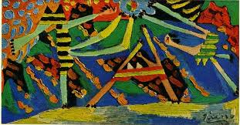  Pablo Picasso | Aboriginal art  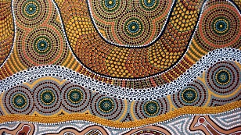 | Pablo Picasso  Paul Klee  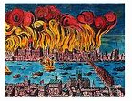  https://www.grangeracademic.com/results.asp?image=0030489&itemw=3&itemf=0001&itemstep=1&itemx=1 | Christo and Jean Claude  https://craftwhack.com/kids-learn-installation-art-christo-and-jeanne-claude/  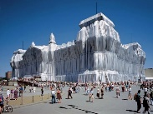 | Carl Warner  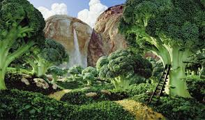  https://kidsartists.blogspot.com/2010/04/foodscape-in-style-of-carl-warner.html  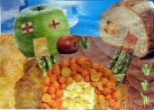 | Claude Monet  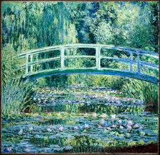  Vincent Van Gogh
DT | Design, make Puppets to create our own Punch and Judy story  Textiles |  | Design and make a fire engine with moving parts  Levers and axles |  | Design a health packed lunch, fruit salad  Food
Computing | - use technology purposefully to create, organise, store, manipulate and retrieve digital content  - understand what algorithms are, how they are implemented as programs on digital devices, and that programs execute by following precise and unambiguous instructions  - use logical reasoning to predict the behaviour of simple programs.  - recognise common uses of information technology beyond school  - use technology safely and respectfully, keeping personal information private; identify where to go for help and support when they have concerns about content or contact on the internet or other online technologies  - use technology purposefully to create, organise, store, manipulate and retrieve digital content  - recognise common uses of information technology beyond school  - recognise common uses of information technology beyond school
 | Purple Mash – Unit 2.6 creating picture(5 tasks )  Unit 2.5 effective research (3 tasks) | Unit 2.1 –coding (5 tasks) | unit 2.7 making music (3 tasks)  unit 2.3- spreadsheets  5 tasks) | unit 2.2 online safety  (4 tasks) | Unit 2 .8-presenting data  (5 tasks ) | Unit 2.4 questioning  (5 tasks)
Music | - use their voices expressively and creatively by singing songs and speaking chants and rhymes  - play tuned and untuned instruments musically  - listen with concentration and understanding to a range of high-quality live and recorded music  - experiment with, create, select and combine sounds using the inter-related dimensions of music
 | Charanga: Hands, Feet, heart | Charanga: Ho, Ho, Ho | Charanga: I Wanna Play in a Band. | Charanga: Zoo Time | Charanga: Pop, Soul, Film, Musicals  . | Charanga: Reflect, Rewind and Replay
PE | - master basic movements including running, jumping, throwing and catching, as well as developing balance, agility and co-ordination, and begin to apply these in a range of activities  - participate in team games, developing simple tactics for attacking and defending  - perform dances using simple movement patterns.
 | Ball Skills | Dance | Gymnastics | Gymnastics | Net and Wall Games | Team Games
PHSE | Introduce Yasmin and Tom  Feelings : Different emotions | Relationships: Different families and friends | Keeping safe: Medicine  Keeping safe: Good and Bad Touch  Keeping Safe: Secrets | Online Safety | Gender: Stereotypes and Toys | Relationships: Friendships and Feelings
RE | 1.2 Who is a Muslim and what do they believe? | 1.6 (part 2) How and why do we celebrate special and sacred times? | 1.3 Who is Jewish and what do they believe? | 1.4 What can we learn from sacred books? | 1.8 How should we care for the others and the world?

