Breckon Hill Primary School Curriculum Our Vision
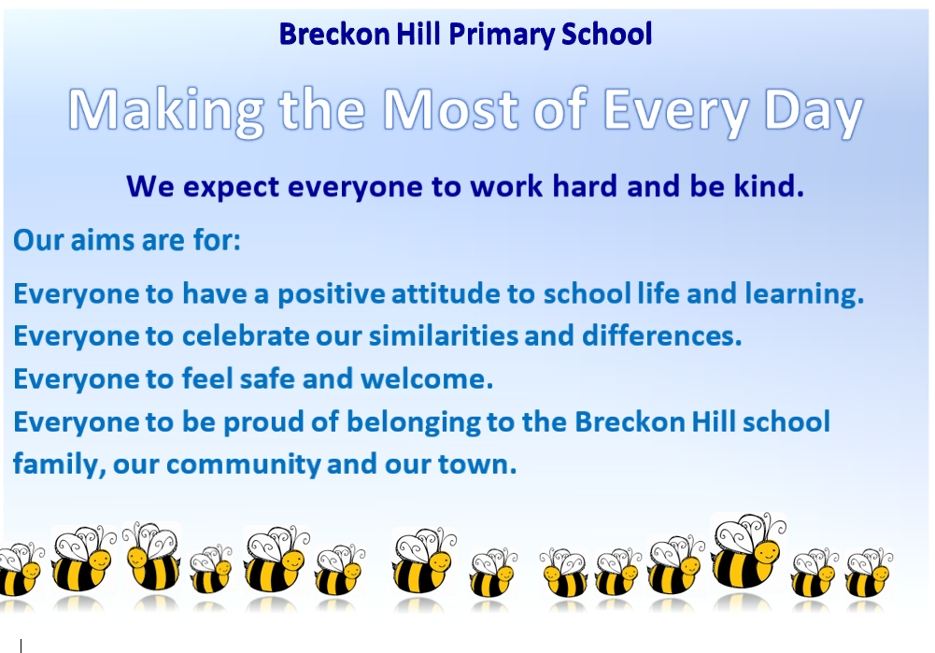
Principles and Purpose  What do we want to achieve and why do we want to achieve it? | BELONGING  We want to develop strong sense of belonging to make sure children feel they are wanted, that they are cared for and valued. | IDENTITY & CULTURE  We want to develop a strong sense of self of who they are and that they are equal. |  |  |  | HUMAN RIGHTS, DEMOCRACY & JUSTICE  We want to encourage respect and tolerance for difference, to empower children to tackle prejudice, improve relationships and make the most of their lives. |  |  |  | WORK HARD  We want to develop determination, attentiveness, responsibility, problem-solving, and self-control. These lessons, in turn, serve us in other areas (health, relationships, hobbies, etc.). |  | INCLUSIVITY  We want everyone to respect diversity, we are all equal and no one is more important than anyone else regardless of  gender, race, religion, belief or disability. |  |  | PERSONAL BEST  We want everyone to strive to be better than last time, every time. This personal best only compares with self, and hence is their control. |  |  |  |  | RELEVANCE  We want to make sure our curriculum meets the needs, interests, aspirations and expectations of our children and society in general. |  |  |  | LEADING A HEALTHY LIFE  We want to create positive attitudes toward children understanding and manging their own health and well-being, both physically and emotionally so this promotes healthy behaviours in life.
Shared Values  Relating to:  self  family and others  local and global community  the environment | Keeping Healthy and Safe |  | Respect |  | Kindness |  | Teamwork |  |  | Determination |  |  | Self-belief | Passion |  |  |  | Care for the environment |  |  | Fair Play |  | Honesty
Key competencies  What key competencies do we need for a successful life? | Managing self Being self-motivated, having a can-do attitude, understanding yourself as a learner and a person, having the ability to reflect and change. |  |  | Relationships Relating well to a diverse range of people involves skills such as:  listening actively, recognising different points of view, negotiating and sharing ideas, cooperate and work in teams. The ability to resolve conflicts. |  |  |  |  |  |  | Using language, symbols and texts  This means how we make meaning – how we express and communicate our ideas, experiences, and information. People use a rich mix of language, symbols and texts, including spoken and written language, visual language such as photos and video, the symbols used in maths and science and much more. It is crucial for 21st century learners to have strong capabilities in this area. |  |  |  |  | Thinking critically  Thinking involves using creative and critical processes to make sense of information, experiences, and ideas. |  |  |  |  |  | Participating and contributing  You don’t learn much if you don’t participate. Learning is active and most of us know that you get more out of any sort of interactions where you also contribute. This competency includes contributing in a group, making connections with others and creating opportunities for others. This relates to every part of our children’s lives
Effective  pedagogy | Creating a positive learning environment |  |  | Connecting prior learning |  |  |  |  |  |  | Fostering reflective practice |  |  |  |  | Making learning meaningful |  |  |  |  |  | Supporting individual differences
Focus for learning | Knowledge Skills Values and Attitudes
The Big Ideas | Continuity and Change  - Change can generate more change.  - Change can be positive or negative.  - Change is inevitable.  - Change is necessary for growth.  - Change can be evolutionary or revolutionary. |  |  |  |  |  |  |  | Exploration  - Exploration confronts the unknown.  - Exploration may result in learning something new or confirming things we already know. |  |  |  |  |  |  |  |  |  | Identity, belonging and difference  - What makes us different?  - What makes us the same?  - Can I get along with others?  - Am I proud of who I am?
Whole School Overview
 | Autumn 1 |  | Autumn 2 |  |  |  |  | Spring 1 |  |  |  |  | Spring 2 |  |  |  | Summer 1 |  |  |  |  |  | Summer 2
EYFS | Who am I?  The Seasons and Weather |  | Do you know your Nursery Rhymes? |  |  |  |  | Why are bears special? |  |  |  |  | Why are these buildings important? |  |  |  | What happens in Springtime? |  |  |  |  |  | Where am I going?
Year 1 | How does our park change through the seasons?  Seasonal Change |  | How have toys changed/stayed the same through time? |  |  |  |  | What do I use my senses for?  Seasonal Change |  |  |  |  | Why are humans not like other animals? |  |  |  | Where do I live and go to school and what is great about Middlesbrough?  Seasonal Change
Year 2 | What was the seaside like 100 years ago? |  | Who is Captain Cook, what did he do and where did he go? |  |  |  |  | Who is Samuel Pepys? |  |  |  |  | Where is our town in our country and where is our country in the UK? |  |  |  | What do we need to grow and be healthy? |  |  |  |  |  | Micro-organisms  Wriggle & Crawl
Year 3 | Who first lived in Britain? |  | Why is eating healthily important? |  |  |  |  | What did the Greeks do for us? |  |  |  |  | Why do people visit the USA? |  |  |  | What makes the Earth angry? |  |  |  |  |  | What does a map of my town look like?
Year 4 | What did we learn from the Romans? |  | What happens to the food we eat? |  |  |  |  | Where in the world is Brazil? |  |  |  |  | Why are rivers important? |  |  |  | Who was involved in the struggle for the Kingdom of England?  How and why has our town changed?
Year 5 | Will we ever return to the moon? |  | Were the Tudors terrific or terrible? |  |  |  |  | How and why do towns and cities grow? |  |  |  |  | Why do people visit France? |  |  |  | What was life like in Victorian Britain? |  |  |  |  |  | Do all animals and plants start life as an egg?
Year 6 | Who were the Maya and where did they live? |  | How did WW2 impact people’s lives? |  |  |  |  | Who inspires us and why? |  |  |  |  |  |  |  |  | What was special about the Ancient Egyptians?

How do we Evaluate Impact? | - Assessments of and for learning  - Feedback  - Talk with children, talk with teachers  - Reflecting on learning and creating a continuous improvement cycle
Accountability Measures | National Standards progress and attainment  Behaviour and attitudes  Making positive choices  Contribution to school and community life  Positive transition to next phase of learning

