ART Scheme of Work Overview Learning about and from
 |  | Autumn 1 | Autumn 2 | Spring 1 | Spring 2 | Summer 1 | Summer 2
EYFS |  | ALL ABOUT ME | THE LAND OF MAKE BELIEVE (NURSERY RHYMES) | BEARS  Who is going down in the woods today? | HOMES | NEW LIFE | JOURNEYS
 | Drawing | Variety for drawing tools and materials
 | Painting | - Mixed poster paint  - Powder paint for children to explore colour through colour mixing independently
 | Core Experiences  M=Major focus  m=minor focus | Drawing M  Painting m  Printing (found objects/rubbings) m | Drawing  Painting M  Printing (found objects/rubbings) m  Craft-Yarn wrapping-stick man | Drawing M  Painting  Sculpture (plasticine) M  Sculpture (Junk ) M | Drawing M  Painting  Collage(shapes)m  Sculpture (Junk ) m | Drawing M  Painting M | Drawing m  Painting m  Sculpture(junk) M
 | Artists  Designers  Craft makers | Joan Miro(painter and sculptor) Mackenzie Thorpe  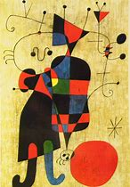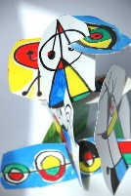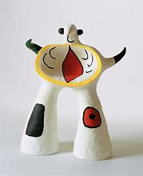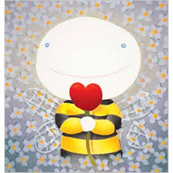 |  | Paul Klee  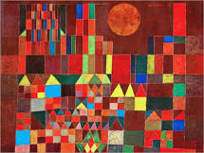 |  | Vincent Van Gogh  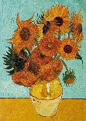
Year 1 |  | How does our park change through the seasons? | What toys did children play with a long time ago? | What do I use my senses for? | Why are humans not like other animals? | Where do I live and go to school?  (Town and country)
 | Drawing | Variety for drawing tools and materials
 | Painting | - Mixed poster paint  - Powder paint for children to explore colour through colour mixing independently
 | Core Experiences  M=Major focus  m=minor focus | Drawing m  Painting M  Printing (found objects/rubbings) M | Drawing (flowers)m  Painting m  Sculpture (3D flowers) M | Drawing  Painting m  Craft(felt-making and sewing)M | Drawing (animals) m  Painting  Craft M (paper weaving) | Drawing (charcoal/chalks) M  Painting  Printing (stick like objects) M  Sculpture-Land Art m  ( Country park visit-Photogtraphs)  Craft-Yarn wrapping
 | Artists  Designers  Craft makers | Umbrellas- Renoir Henri Matisse  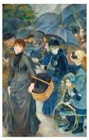 | Oriental Poppies Georgia O’Keeffe  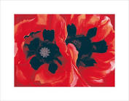  Pieter Bruegel children’s games  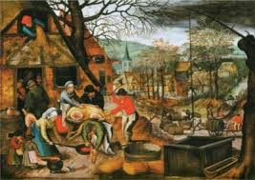 | Wassily Kandinsky  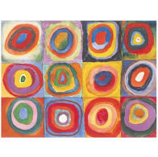 | Tiger in a Tropical Storm Henri Rousseau  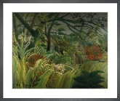 | LS Lowry  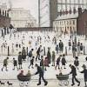
Year 2 |  | What was the seaside like 100 years ago? | Who is Captain Cook, what did he do and where did he go? | Who is Samuel Pepys? | Where is our town in our country and where is our country in the UK? | What do we need to grow and be healthy? | What is a micro-organism?
 | Drawing | Variety for drawing tools and materials
 | Painting | - Mixed poster paint  - Powder paint for children to explore colour through colour mixing independently  - Watercolours
 | Core Experiences  M=Major focus  m=minor focus | Drawing m  Painting M  Collage, sculpture, paper mache m | Drawing  Painting  Printing M  Craft (Tie-dye) m | Drawing (line drawings) M  Painting m | Drawing (human and physical features of the local area) M  Painting  Printing using repeated images of buildings M  Sculpture(junk landmarks-wrapping )M | Drawing (charcoal/chalks) M  Painting  Collage(food pictures/ variety of paper textures/dried food) M | Drawing m  Painting  Craft (flower pressing, felt-making and sewing) M
 | Artists  Designers  Craft makers | Longships Lighthouse, Land’s End by artist Joseph Mallord William Turner  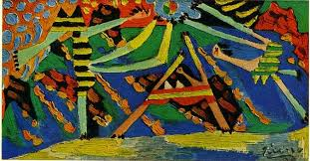  Pablo Picasso  Sculpture-Land Art m  ( Saltburn visit-Photographs) | Aboriginal art  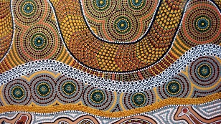 | 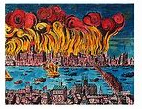  https://www.grangeracademic.com/results.asp?image=0030489&itemw=3&itemf=0001&itemstep=1&itemx=1 | Christo and Jean Claude  https://craftwhack.com/kids-learn-installation-art-christo-and-jeanne-claude/  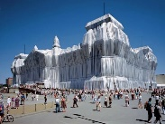 | Carl Warner  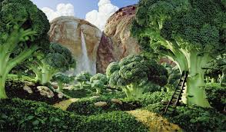  https://kidsartists.blogspot.com/2010/04/foodscape-in-style-of-carl-warner.html  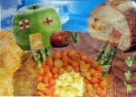 | Claude Monet  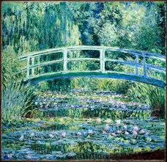
Year 3 |  | Who first lived in Britain? | Why is eating healthily important? | What did the Greeks do for us? | Why do people visit the USA? | What makes the Earth angry? | What does a map of my town look like?
 | Core Experiences  M=Major focus  m=minor focus | Drawing (Charcoal and chalks) M  Painting m | Drawing  Painting  Collage (using pictures of food) m  Food sculpture(tissue and plastic mache)M | Drawing m  Painting m  Printing/ mosaics m  Sculpture (clay, papier mache) M | Drawing m  Painting  Sculptures(tin foil people with shadows)M  Craft Weaving (dream catchers)M | Drawing  Painting M  Printing (press printing) m | Drawing m  Painting m  Sculpture(junk) M
 | Artists  Designers  Craft makers | Ancient Britain, The Stone Age The British Museum website  http://teachinghistory100.org/browse/curriculum/2/  https://www.britishmuseum.org/learn/schools/ages-7-11/ancient-britain/visit-resource-prehistoric-britain | Giuseppe Arcimboldo  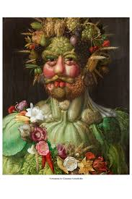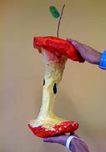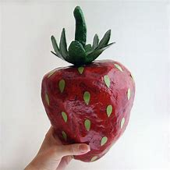 | The British Museum website  http://www.ancientgreece.co.uk/  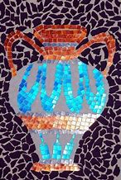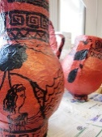  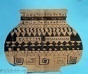 | Linda Apple  https://fineartamerica. com/featured/off-to-work-shadows-painting-linda-apple.html  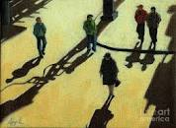 | The Great Wave Katishika Hokusai  https://www.deepspacesparkle .com/the-great-wave-art-lesson-plan-video/  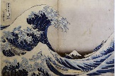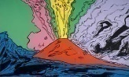  Andy Warhol Vesuvius | McKenzie Thorpe  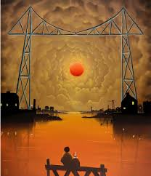
Year 4 |  | What did we learn from the Romans? | What happens to the food we eat? | Why is a Carnival so noisy? | Why is the River Tees so important? | Who was involved in the struggle for the Kingdom of England? | How and why has our town changed?
 | Core Experiences  M=Major focus  m=minor focus | Drawing m  Painting M  Printing (found objects/rubbings) M | Drawing  Painting M  Printing (found objects/rubbings) m | Drawing  Painting  Printing m  Mask making | Drawing  Painting M | Drawing  Painting  Printing (press printing) m  Buckles and Jewellery design,M illuminated letters m  Felt making and stitching-running stitch.M  (History Link) | Drawing m  Painting m  Sculpture(junk) M
 | Artists  Designers  Craft makers | A Roman Triumph  https://www.nationalgallery. org.uk /media/31342/teachers-notes-rubens-2016.pdf  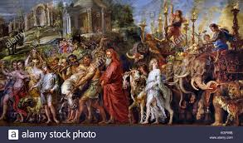 | Study Damien Hirst and Antoni Gaudi. Replicate an animal collage in the style of Gaudi  (Science Link) | Fauvism  Continuing the Narrative: Take a Journey Through a Painting  The Story of Joseph Biagio d'Antonio  RE LINK  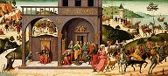 | 'Men of the Docks'  George Bellows  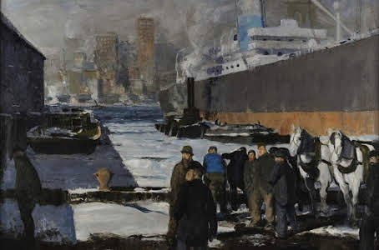  https://www.nationalgallery.org.uk /media/31343/national-gallery-teachers-notes-2018_9.pdf  Seurat The Bathers | Bayeux tapestry  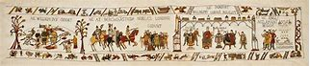
Year 5 |  | Will we ever return to the moon? | Were the Tudors terrific or terrible? | How and why do cities and towns grow? | Why do people visit France? | What was life like in Victorian Britain? | Do all animals and plants start life as an egg?
 | Core Experiences  M=Major focus  m=minor focus | Drawing m  Painting M  Printing (found objects/rubbings) M | Drawing m  Painting  Craft and making(textiles) M | Drawing  Painting  Sculpture(sticks, wire, tissue, paper mache, junk modelling) M | Drawing  Painting M | Drawing  Painting M  Printing(press printing) m | Drawing m  Painting  Craft and making Sculpture(junk) M
 | Artists  Designers  Craft makers | Peter Thorpe  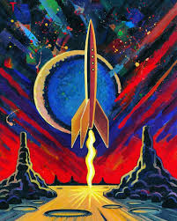  Pandora artwork | The Ambassadors Hans Holbein  https://www.national gallery. org.uk/media/31357/notes _holbein-ambassadors.pdf  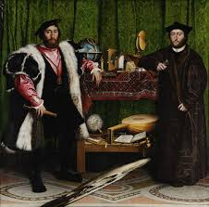 | Architects | French Artists | William Morris  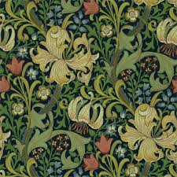  Christopher Dresser (Dorman Museum) | Robert Hooke, Rosalind Monks, Joel Armstrong  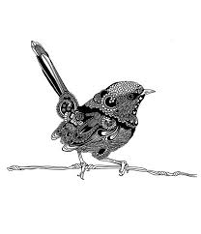
 |  | Who were the Mayans and where did they live? | How did WW2 impact people’s lives? | Who inspires us and why? |  | What was special about the Ancient Egyptians?
 | Core Experiences  M=Major focus  m=minor focus | Drawing m  Painting M  Printing (found objects/rubbings) M | Drawing M  Painting  Sculptures m | Drawing m  Painting M |  | Drawing m  Painting  Sculpture(clay) M
Year 6 | Artists  Designers  Craft makers | Mayan sculpture  https://www.incredibleart.org/lessons/elem/loganmayan.html  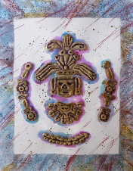 | Henry Moore- Shelter drwaings  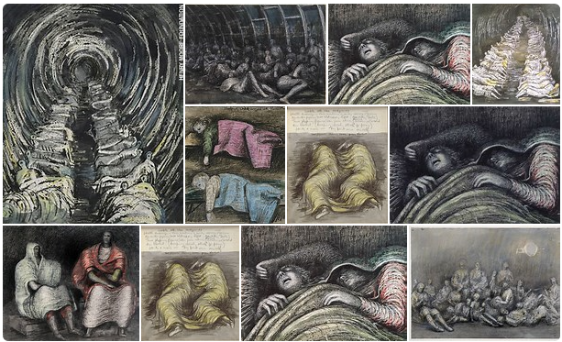 | Georges Seurat  Pointillism  https://www.bbc.co.uk/bitesize/clips/zgmkp39  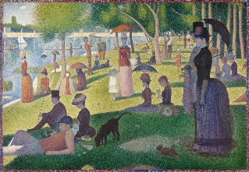 |  | Ancient Egypt  https://www.britishmuseum.org/learn/schools/ages-7-11/ancient-egypt  