Numbers  Play “I spy numbers” – How many numbers can you find?  Inside the house – clock, oven dial, calendar, remote control  Outside – numbers on doors, road signs etc. Can you name and write the numbers?  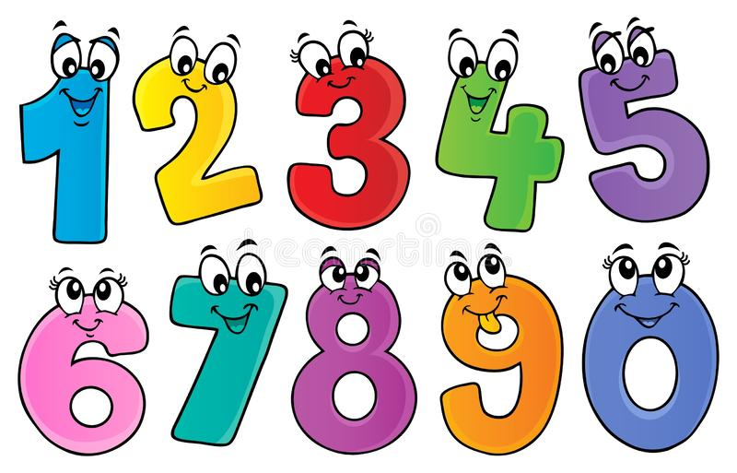 | Nursery Activity Worksheet  Junk Model Fun  Use old boxes, cartons, cardboard and crates to build dens, boats, trains, cars etc. | Pasta Fun  Thread pasta on string, wool or straws. Make bracelets, necklaces or counting pasta straw towers.  Collage  Use different shaped pasta to make a collage picture. Coloured pasta can be used too.  Make a pattern or a fish.  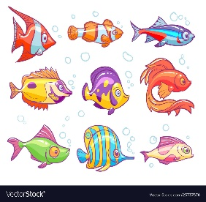
Keeping Fit  10 jumps on the spot  10 hops (each leg)  10 seconds balance on one leg  10 star jumps  Then repeat  Joe Wicks daily on YouTube | Name Strip Jigsaw  Write you name on paper or card. Cut the name into letter strips (1 letter per strip). Mix the strips up and put them back into the correct order.  “I Spy Letter” Game  Can you find the letters from your name around your house? – in newspapers, books, calendars etc. | Newspaper Page/Old Leaflet  Choose each letter from your name and circle each letter a different colour. Include both capital and lower case letters.  For example David – circle every Dd green, every Aa red.  David had a dog named Doodle.

