Butterfly Kingdom

**Let’s dance!**

Can you…

1. Crawl like a caterpillar without using your hands or feet
2. Roll up in a chrysalis
3. Flap your wings up high and down low?
4. Keep your feet together and jump from flower to flower

Or, try this:

<https://www.youtube.com/watch?v=Lkza_tRlNRE>

**Song time**

Butterfly songs

<https://www.youtube.com/watch?v=1EQeYA5Qbic>

**Poetry writing**

Try writing an acrostic poem using the word Butterfly.

Think of a describing word for each letter…I’ll start you off.

**B**eautiful

**U**p in the sky

**T**umbling around

**T**

**E**

**R**

**F**

**L**

**Y**

**Number work**

Doubles – 1+1, 2+2, 3+3, 4+4, 5+5

Put the same number of counters / pasta / pebbles on each wing, how many all together?

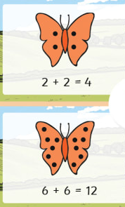

**Scissor practise**

Fold a piece of paper in half and cut away from the fold to make a symmetrical butterfly.

Can you decorate it to look like a real butterfly – reflected on each wing? 