Year 5B Homework Grid – W/C: 18/05/20
Please complete the tasks in this grid:

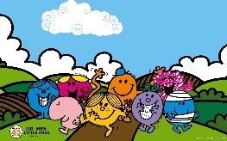  1) Create a collage of your favourite Mr Man or Little Miss. | 5) Label all the 2D shapes that you can spot around your bedroom. | 9) How many different ways can you make 50p? | 13) See how many challenges you can complete in Education City
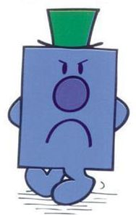  2) This is Mr Grumpy.  Can you write a change story telling me why he is so grumpy and how he changes to become happy? | 6) How many different number bonds can you write to make 100? | 10) Plan a healthy meal for you and your family to eat. | 14) Find some famous buildings and structures in France. Can you recreate one of these? Try using empty cartons from around your home.  This Photo by Unknown Author is licensed under CC BY-SA
3) Learn a new skill around the house, such as washing the windows or ironing. | 7) Start at 0 and count in steps of 3 then 4. How far can you count? How many times do you see the same number in both sequences? | 11) Design a new front cover for our class novel ‘Ratburger’ by David Walliams. | 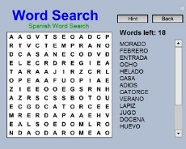  15) Make a word search about different Mr Men.
4) Use 2Animate in Purple Mash to show how a tadpole changes into a frog. | 8) I’m missing you all, please can you write me a letter describing a Mr Man to make me smile? | 12) Bake a cake with a rainbow theme.  This Photo by Unknown Author is licensed under CC BY-SA | 16) Make a list of words that have different spellings of the /s/ sounds in them. (<s>, <ss>, <st>, <c>, <ce>, <se>, <sc>)

