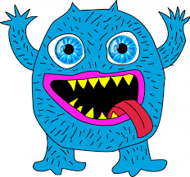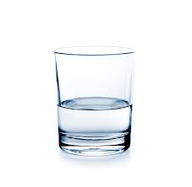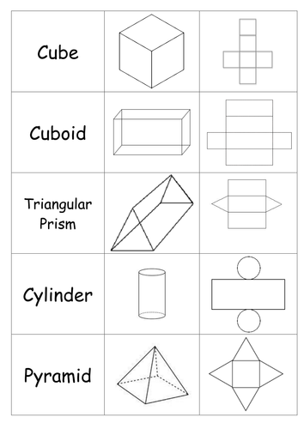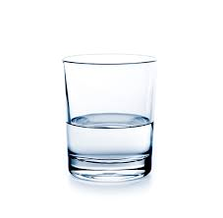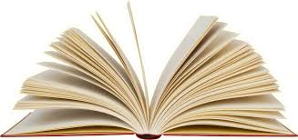

**Y4 Homework Challenges**

**Can you design your own monster?** Use things from around the house to make it and then write a fact file – What does it eat? Where is it from? What does it look like?

**Science Enquiry**

Mix together salt and water, make sure it dissolves.

Now can you try and separate them?

**Clue!** Think of one of the processes in the water cycle.

**Challenge!** Mix together salt and pepper – can you separate them?

Now write you own **Beat the Monster** **story** featuring your very own monster! Is it going to be good or evil?

**Maths Challenge!**

Look around your house, how many different 3D shapes can you find? Can you...

* Make a table showing how many different 3D shapes you can find in your house.
* Can you use paper and a net and make your own 3D shapes?
* Design your own school building using 3D shapes, make a model or draw it. Can you make it a fun and exciting school building?
* I am a 3D shape, I have 6 faces that are all the same shape, 12 edges, I am a ….
* Can you make your own puzzles for your family? Who gets the most correct?

**Fun story or poem!**

Open a book at **a** random page, use the **back** of a cereal box, **a** magazine, newspaper or website. **Anything** with writing, the more **interesting** the better.

Write down **every** fifth word, I’ve coloured **the** fifth ones in this **piece.**

Now write a funny **short** story or poem using **the** words in order!

**Maths Anagrams**

Can you work out what the muddled-up words are? Can you create maths problems for your family using the words?

* t c a i u l c o l a n
* a t c l i m i t u o p l i n
* d b i u o c
* n e g a l
* n o i i s i d v
* a q u e l
* l a r l l p a e

**Mackenzie Thorpe**

**This is a piece of art by Mackenzie Thorpe**

It shows a picture of the Transported Bridge in Middlesbrough.

* Can you write a story about the people in the piece of art? Who are they? What are they doing? Where are they from?
* Look at the shapes you can see in the art piece, have a go at drawing just the shapes you can see in the right place on a piece of paper.
* Have a look at other landmarks in Middlesbrough – the Temenos, Bottle of Notes etc. Have a go at drawing them in the same style Mackenzie Thorpe has created this picture.
* Would it have the same effect if it was the same picture but a different time of day? Have a go at drawing or painting it in the morning or sunset.

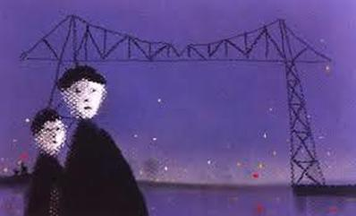

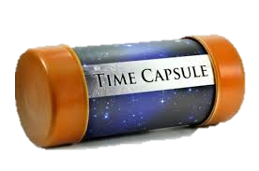

**Don’t forget to enjoy time at home with family!**

**Learn to bake something new and tasty.**

**Help siblings with their homework.**

**Create your own games!**

**Read a family book.**

**History Challenge!**

You are living in a time that will be in future history books. Schools closed! You couldn’t go out and see friends and family! People were buying lots and lots and lots of toilet roll!

Can you make a Time Capsule to remember this period in history?

Think about including:

* A diary entry
* Photos or pictures
* A message written on a piece of toilet roll!
* Be creative, if you were from the future what would you want to know about living in lockdown?