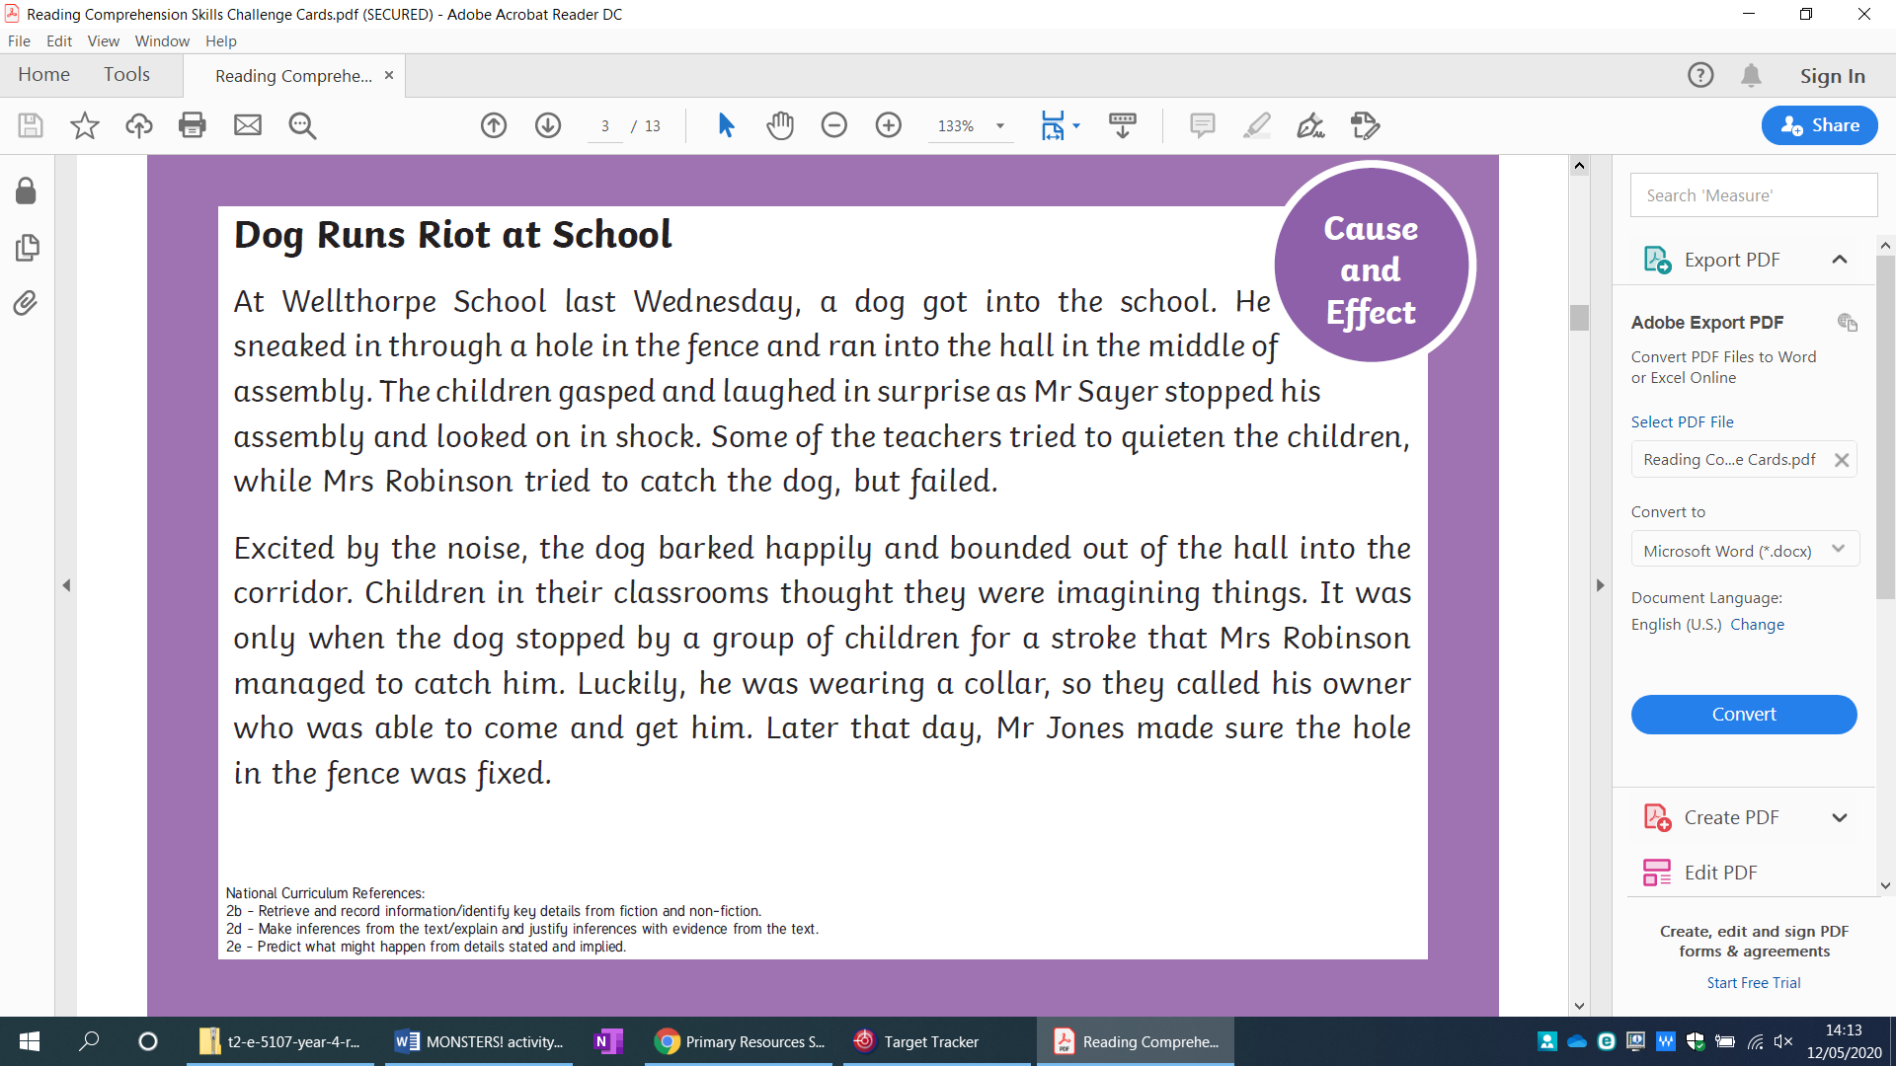

* **Enjoy reading your own book at home**
* **Bake a cake, if you can’t draw and design what you’d like to make**
* **Draw a still picture of what you can see out of your house**
* **Create a video of you telling a story, you could act it out**

Read the text Dog Runs Riot at School. Can you:

What does **riot** mean? Please don’t run riot at home, you’ll drive your parents crazy!

* Change the ending?
* Change the characters? What else might run riot in school?
* Are there any adjectives? Can you add some to make it more interesting?
* Write down every 6th word, can you use them to create your own fun song, rap or story using the words?

**Maths Challenge**

Role a dice (or use bits of paper folded up with the numbers 1-6 written on them) 4 times.

1. How many different 4-digit numbers can you make?
2. Play with a family member – add them together. Winner is the highest score.

You can change this to only using 2 or 3 digit numbers. The winner could be the closest to 10,000 or the one with the lowest score…….

You make your own rules for the game.

 

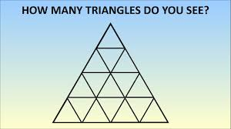

This is a map of the England and Wales with Roman roads and their names.

Can you have a look at a map of today and see if the Roman roads are still there? Do they have the same name?

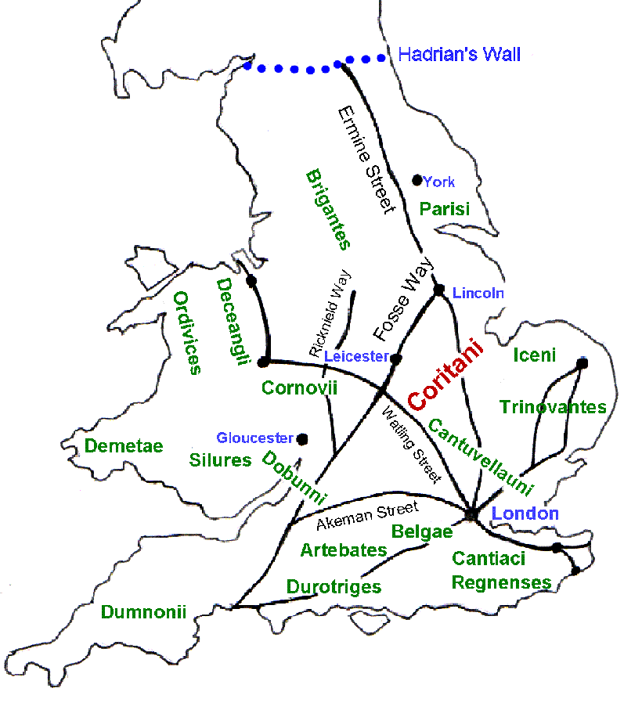

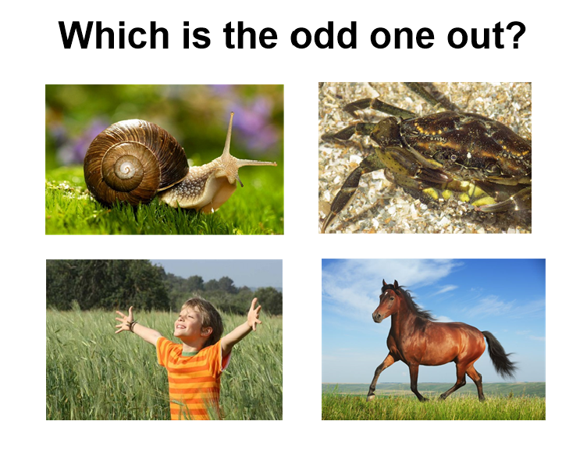

**How do you know? Does your family agree with you?**