Check it out:
https://www.thenational.academy/online-classroom/
This website has daily online lessons with an onscreen teacher

Year 1 Homework grid
Year 1 Homework Grid
To find out more about VE Day, you can read this article which will provide a range of information and help to set the scene  https://www.bbc.co.uk/newsround/48201749  https://www.bbc.co.uk/cbbc/watch/horrible-histories-songs-ve-day-song  It is the perfect time to compare the differences between how life is at the moment and how life was during the war, on VE Day and after the war.  Create a fact file to tell people all about VE Day using the information you found out. You could do this by writing a fact file, creating a poster or creating a PowerPoint presentation. | English – Word classes.  Can you sort the words below into three lists? A list of nouns, verbs and adjectives.  bike dancing black  jumping thinking  beautiful cup singing  soft car England  chair long shiny  walking smiled  laughed frog clapped  bed sticky glass | Money money money!  During WW2 and afterwards food was rationed so it didn’t run out. Look at the food rations list below. You have 10p to spend on food. What can you buy? How many ways can you spend your 10p? Use your knowledge of number bonds to ten to help you.  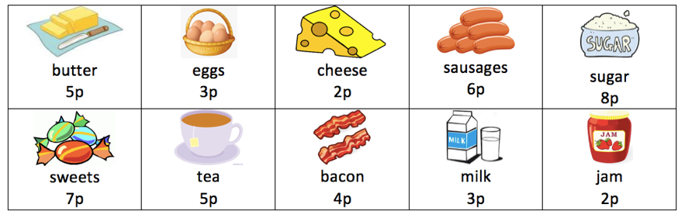 | History/English - Writing  Look carefully at the pictures below. What can you see? What do you think is happening? Write a sentence or sentences to explain what you think is happening.  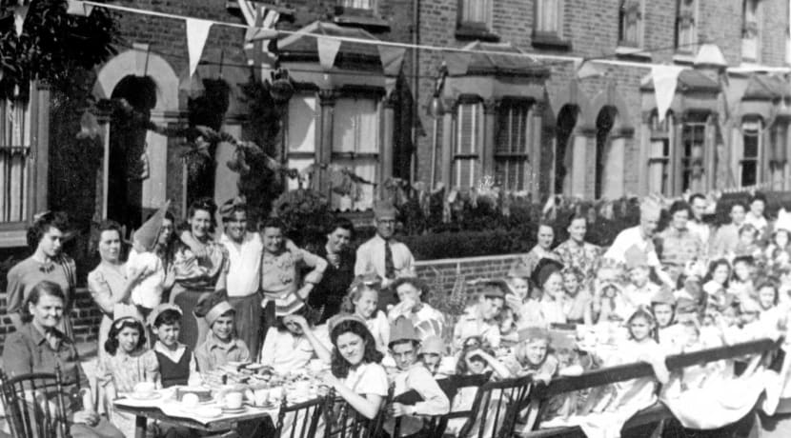  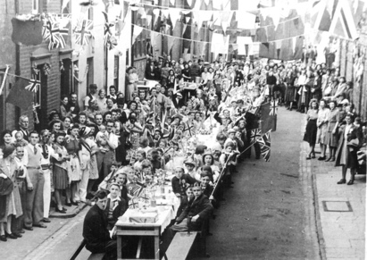
Learn a joke to make people laugh, because laughing is great!  Miss Pearcy’s joke for you:  Question: Why did the orange go to the doctors?  Answer: Because it wasn’t peeling very well.  I hope to hear some of the jokes you learn soon.  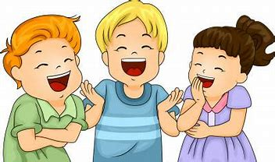 | ART  Can you create a picture using objects you find in your garden or on your daily walk.  Write a few sentences using adjectives to describe your creation.  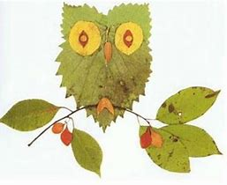  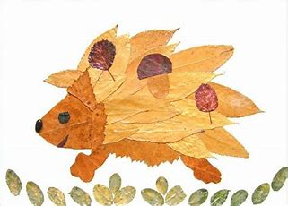 | English - Singular or plural?  Look at the words below and decide if they are singular (one) or plural (more than one). Make a list of each.  cat man ladies ducks friend  dogs men mouse hat pen eggs  mice flower chairs stories  pencil girls boy toys laptop  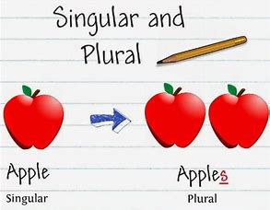 | Write an acrostic poem  This is one about the NHS which stands for National Health Service. Lots of people work for the NHS like doctors and nurses and they are doing a great job now trying to make poorly people better.  N ice people all over the world  H elping so many people  S super heroes saving lives.  Stay safe! 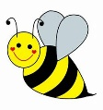
Fractions  Can you make a fractions poster to show half and a quarter of a shape? Remember fractions are always equal parts.  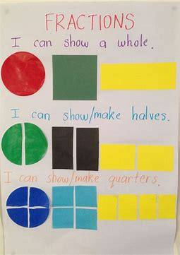 | Plants  We learned the parts of a plant at the beginning of the year. Can you remember what each part is called and why it’s important.  Can you name common trees and plants that you see near your home?  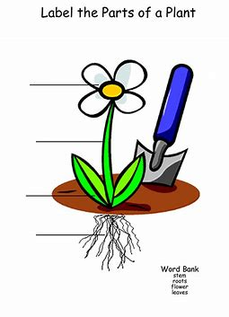 | Shadows  Look at your own shadow and notice if it changes throughout the day. What light source is making your shadow?  Can you have shadows without light?  What does dark mean?  You could also do some shadow tracing and draw objects from you home. | Tens and ones  Match the statement to the number.  