WATCH and LEARN  Go to BBC Bitesize KS2 Geography on The Natural World. Watch the Videos on Weather, Volcanos and Earthquakes.  https://www.bbc.co.uk/bitesize/topics/z849q6f | 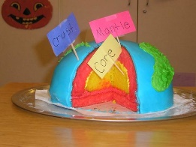  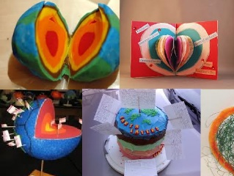  Draw or make a cross section of the earth and label the layers of the Earth. You could even bake a cake and use food colouring! Take a picture to show me! | 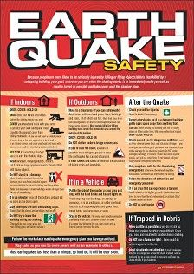  Design a leaflet to explain what people should do if an earthquake happens.  How can they stay safe?  Also earthquakes can create a tsunami. What is a tsunami and how can people avoid these? | Draw a cross section of a volcano and label the different parts. 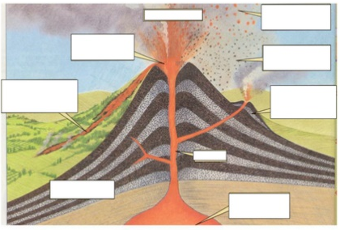
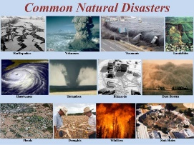  Write a non chronological report and fact file different type of natural disasters. Create a definition and give examples of each and explain what they are. (Draw a picture to help you remember what they are). | 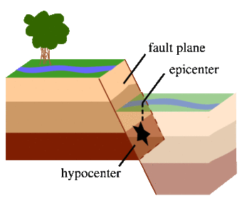  Write an explanation of how the Earth’s crust and tectonic plates create earthquakes. Draw a diagram to help your explanation. | 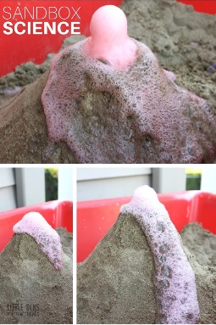  Create a 3D model of a volcano using what ever material you like.  Use baking soda and vinegar to create your own eruption. Or coke and mento. Take a video clip of your eruption to show me! | Create your own tornado model using an empty plastic bottle and water. Watch the video and follow the instructions.  https://www.bbc.co.uk/cbbc/watch/how-to-make-a-tornado-in-a-bottle-experiment
Using a map of the world and a computer to research and locate where is the world different natural disasters happen. Tornados, volcano eruptions, tsunamis, wild fires, monsoon, etc. Create a key and draw the symbol of the natural disaster on the country.  Map available on the Y3 learning zone on the school website. | 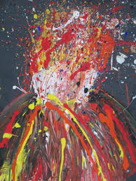  Create a painting of a volcano eruption or a lightning storm. Try using a straw to blow the paint to create the explosion at the top of the volcano or the lightning in the storm over the mountains. | Watch newsround to find out the latest news from around the world.  Pretend you are a news or weather reporter and you are reporting on a natural disaster.  Video record yourself explaining what is happening and what people should do to stay safe. Do it sitting at a table like the reporters in the studio or in your garden like a weather presenter. Make it up, use props- be dramatic! | Write a poem about a volcano eruption. Describe what you can see, hear, smell and feel, Use adjectives, alliteration and similes to describe different parts of the volcano: (smelly smoke as dark as, lava as hot as, rough ragged rocks flying like). Watch some video of volcano eruptions on youtube to help you.
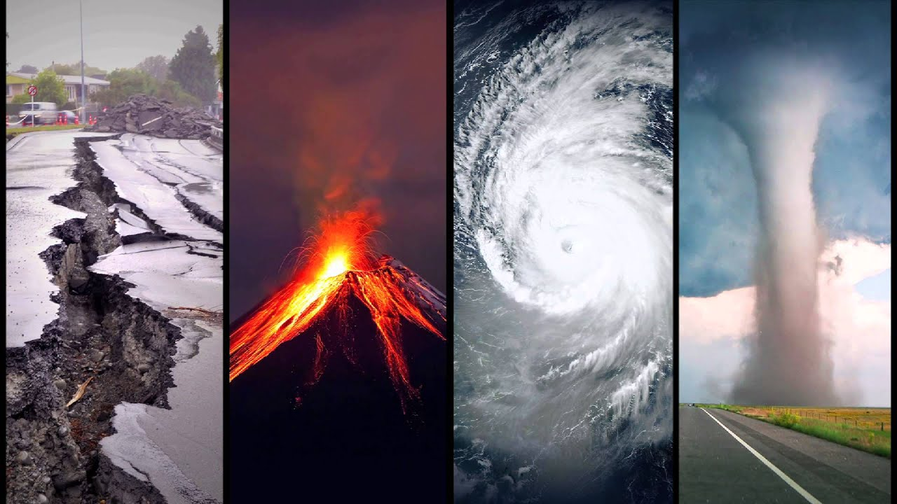
Extreme Home Learning Grid (Keep all your home learning work including photos and videos we want to see your wow work)

