**Song time**

(Lots of versions online)

Old MacDonald

Dingle Dangle Scarecrow

BINGO

5 Little Ducks

5 Little Speckled Frogs

**Cbeebies Iplayer**

Down on the Farm

**Come Outside Videos**

**(15 minutes on YouTube)**

Bread

A Woolly Jumper

Eggs

Geese

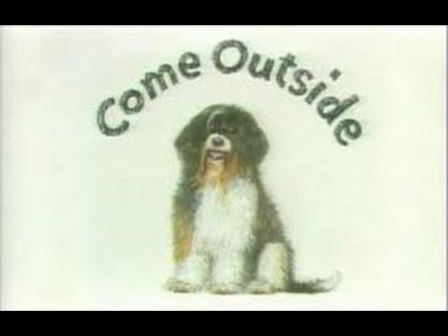

FARM LIFE

**The Little Red Hen Activities**

Watch “Come Outside – Bread” to hear the story.

Act out the story with your family – you could make paper plate masks!

Taste testing different types of bread

White, wholemeal, pitta, baguette, naan, roti, tortilla wraps.

Describe the taste, the texture.

Use the bread to make sandwiches to practise spreading, chopping, slicing, cutting – Remember to use the tools safely and with an adult.

Make Pitta Bread Pizzas with different toppings.

Design pizzas, cut them out and learn to cut them in half or into quarters.

Make some toast then write some instructions to make toast using bossy words.

Draw your own story map.

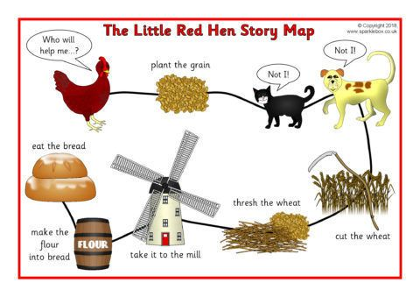

**On the Farm**

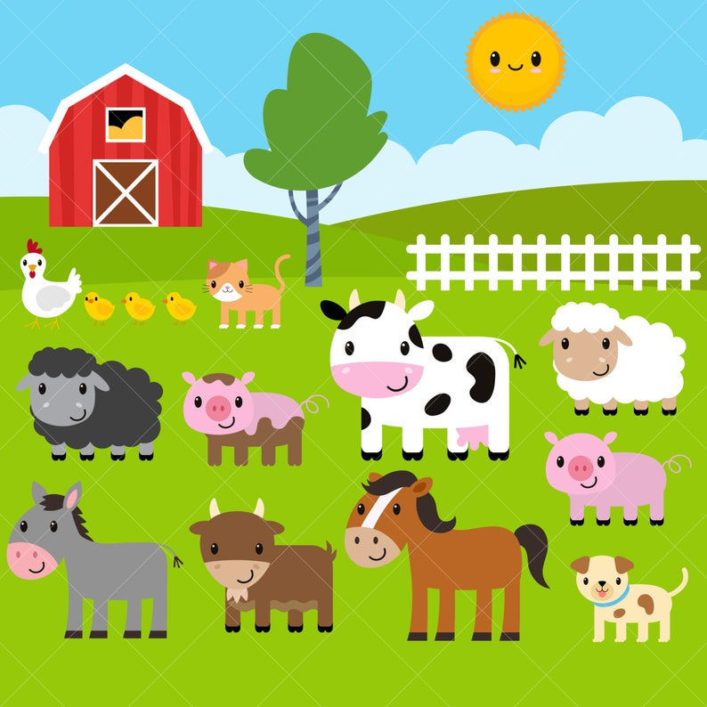

Make a list of farm animals and the names of their babies.

Make a tractor or a farm house using empty boxes – colour/paint/collage it.

A Farm’s not a Farm without…

Design a farm drawing the key features and the animals that you would choose to have. Will it have a pond? Will it have crops? What animals will you have and where will they live. Don’t forget your farm house.

Draw a big picture of your favourite farm animals, colour, paint or collage it.