 | Theme 1 | Theme 2 |  | Theme 3 |  | Theme 4 |  | Theme 5 |  | Theme 6
Driver | History  8 weeks | Science  7 weeks |  | History  6 weeks |  | Geography  7 weeks |  | Science  5 weeks |  | Geography  6 weeks
Theme Title | Who first lived in Britain? | Why is eating healthily important? |  | What did the Greeks do for us? |  | Why do people visit the USA? |  | What makes the Earth angry? |  | What does a map of my town look like?
Why this topic and why now?  (Rationale) | Beginning of the historical timeline in KS2 and the start of early human cilivisation.  Children begin to undersand the language of chronology | Children are building on knowledge of the human body and learning about nutrition and how to keep healthy. |  | Moving in chronological order on the historical timeline. Understanding how the Anicent Greeks lived and have influenced the Modern World.  Children begin to undersand the language of chronology |  | Building on the locational knowledge of the UK and the physical and human vocabulary learnt in KS1 to begin comparing and contrasting our local area with states and towns in the USA. |  | Building on KS1 knolwedge of material propertites to understand magnetic forces.  Widening world locational knowledge to look at how climate can influence natural disasters. |  | Building on basic fieldwork and map skills learnt in KS1 to conduct fieldwork and develop understanding of geographical postion and draw their own simple map of Middlesbrough town.
Enrichment | Stone Age workshop visitor | Theatre Visit |  | Performance |  |  |  | Volcano experiment |  | Local Area Visit  Sports Week
Remembering Experience | Quiz |  |  | Museum in the Classroom |  |  |  | Parent Work Share
Science | Rocks  - compare and group together different kinds of rocks on the basis of their appearance and simple physical properties  - describe in simple terms how fossils are formed when things that have lived are trapped within rock  - recognise that soils are made from rocks and organic matter. | Animals including humans  - identify that animals, including humans, need the right types and amount of nutrition, and that they cannot make their own food; they get nutrition from what they eat.  - identify that humans and some other animals have skeletons and muscles for support, protection and movement. |  | Plants  - Identify and describe the functions of different parts of flowering plants: roots, stem/trunk, leaves and flowers  - explore the requirements of plants for life and growth (air, light, water, nutrients from soil, and room to grow) and how they vary from plant to plant  - investigate the way in which water is transported within plants .  - Explore the part that flowers play in the life cycle of flowering plants, including pollination, seed. |  | Light  - recognise that they need light in order to see things and that dark is the absence of light  - notice that light is reflected from surfaces  - recognise that light from the sun can be dangerous and that there are ways to protect their eyes  - recognise that shadows are formed when the light from a light source is blocked by an opaque object  - find patterns in the way that the size of shadows change. |  | Forces and Magnets  - compare how things move on different surfaces  - notice that some forces need contact between two objects, but magnetic forces can act at a distance observe how magnets attract or repel each other and attract some materials and not others  - compare and group together a variety of everyday materials on the basis of whether they are attracted to a magnet, and identify some magnetic materials  - describe magnets as having two poles  - predict whether two magnets will attract or repel each other, depending on which poles are facing.
Geography |  |  |  | Key Geography skills linked to History Ancient Greece  Locational knowledge: countries of Europe; key physical and human characteristics; similarities and differences with the UK |  | Similarities and differences a region of the United Kingdom and a region of North America.  . |  | Mountains, Volcanoes and Earthquakes |  | Middlesbrough study  Mapping Middlesbrough. .
History | Changes in Britain from the Stone Age to the Iron Age  Study of life: Stone, Bronze and Iron Age; farming and technology leading to Claudius’ invasion and conquest of Britain in AD 43 |  |  | Ancient Greece  A study of Greek life and achievements and their influence on the western world. |  | Christopher Columbus |  |  |  | Middlesbrough’s landuse change through photographs and historical maps.
Art  Core Experiences  M=Major focus  m=minor focus | Drawing (Charcoal and chalks) M  Painting m | Drawing  Painting  Collage (using pictures of food) m  Food sculpture(tissue and plastic mache)M |  | Drawing m  Painting m  Printing/ mosaics m  Sculpture (clay, papier mache) M |  | Drawing m  Painting  Sculptures(tin foil people with shadows)M  Craft Weaving (dream catchers)M |  | Drawing  Painting M  Printing (press printing) m |  | Drawing m  Painting m  Sculpture(junk) M
Art  Learning about and from art | The British Museum website  http://teachinghistory100.org/browse/curriculum/2/  https://www.britishmuseum.org/learn/schools/ages-7-11/ancient-britain/visit-resource-prehistoric-britain | Giuseppe Arcimboldo  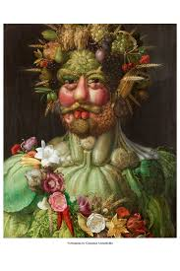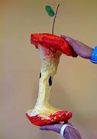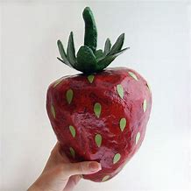 |  | The British Museum website  http://www.ancientgreece.co.uk/  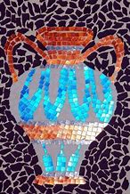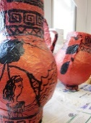  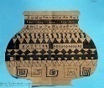 |  | Shadow art  Linda Apple  https://fineartamerica.com/featured/off-to-work-shadows-painting-linda-apple.html  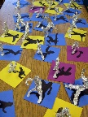  Dream catchers  Totem Poles |  | The Great Wave Katishika Hokusai  https://www.deepspacesparkle .com/the-great-wave-art-lesson-plan-video/  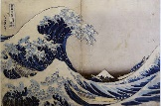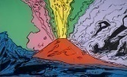  Andy Warhol Vesuvius |  | Study artwork of Lowry, McKenzie Thorpe  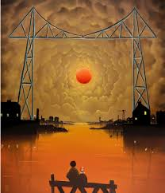  Sketch a famous bridges and design their own art work based on the transporter bridge  David Watson  (Geography/History Link)
Design and Technology | Design and make food packaging,  Make a soup, pizza, cakes.  (Science Link) |  |  |  |  | Design and make  Dream catchers  Totem Poles |  |  |  | Build To The Line  The Design and Construction Challenge for age 8-11  https://www.data.org.uk/resource-shop/build-to-the-line-class-pack/  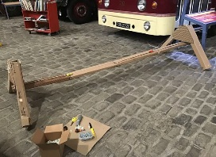
Computing | - design, write and debug programs that accomplish specific goals, including controlling or simulating physical systems; solve problems by decomposing them into smaller parts.  - select, use and combine a variety of software (including internet services) on a range of digital devices to design and create a range of programs, systems and content that accomplish given goals, including collecting, analysing, evaluating and presenting data and information.  - understand computer networks, including the internet; how they can provide multiple services, such as the World Wide Web, and the opportunities they offer for communication and collaboration  - use technology safely, respectfully and responsibly; recognise acceptable/unacceptable behaviour; identify a range of ways to report concerns about content and contact  - use search technologies effectively, appreciate how results are selected and ranked, and be discerning in evaluating digital content  - select, use and combine a variety of software (including internet services) on a range of digital devices to design and create a range of programs, systems and content that accomplish given goals, including collecting, analysing, evaluating and presenting data and information.  - use technology safely, respectfully and responsibly; recognise acceptable/unacceptable behaviour; identify a range of ways to report concerns about content and contact.  - use technology safely, respectfully and responsibly; recognise acceptable/unacceptable behaviour; identify a range of ways to report concerns about content and contact.
 | Purple Mash Unit 3.6: Branching Databases  Purple Mash Unit 3.4: Typing | Purple Mash Unit 3.8: Graphing  Purple Mash Unit 3.3: Spreadsheets |  | Purple Mash Unit 3.5: Emails |  | Purple Mash Unit 3.2: Online Safety |  | Purple Mash Unit 3.7: Simulations |  | Purple Mash Unit 3.1: Coding
Music | - play and perform in solo and ensemble contexts, using their voices and playing musical instruments with increasing accuracy, fluency, control and expression  - improvise and compose music for a range of purposes using the inter-related dimensions of music  - listen with attention to detail and recall sounds with increasing aural memory  - use and understand staff and other musical notations  - appreciate and understand a wide range of high-quality live and recorded music drawn from different traditions and from great composers and musicians  - develop an understanding of the history of music.
 | Charanga: Let Your Spirit Fly |  | Charanga: 3 Little Birds |  | Rehersals for Class Play |  | Charanga: The Dragon Song |  | Charanga: Bringing Us Together |  | Charanga: Reflect, Rewind and Replay
MFL | - listen attentively to spoken language and show understanding by joining in and responding  - explore the patterns and sounds of language through songs and rhymes and link the spelling, sound and meaning of words  - engage in conversations; ask and answer questions; express opinions and respond to those of others; seek clarification and help  - speak in sentences, using familiar vocabulary, phrases and basic language structures  - develop accurate pronunciation and intonation so that others understand when they are reading aloud or using familiar words and phrases  - present ideas and information orally to a range of audiences  - read carefully and show understanding of words, phrases and simple writing  - appreciate stories, songs, poems and rhymes in the language  - broaden their vocabulary and develop their ability to understand new words that are introduced into familiar written material, including through using a dictionary  - write phrases from memory, and adapt these to create new sentences, to express ideas clearly  - describe people, places, things and actions orally and in writing
 | Rigolo Unit 1: Bonjour (Hello!) |  |  |  | Rigolo Unit 2: En classe (Classroom) |  | Rigolo Unit 3: Mon corps (My body) |  | Rigolo Unit 4: Les animaux (Animals) |  | Rigolo Unit 5: Bon anniversaire (Birthday)
PE | - use running, jumping, throwing and catching in isolation and in combination  - play competitive games, modified where appropriate [for example, badminton, basketball, cricket, football, hockey, netball, rounders and tennis], and apply basic principles suitable for attacking and defending  - develop flexibility, strength, technique, control and balance [for example, through athletics and gymnastics]  - perform dances using a range of movement patterns  - take part in outdoor and adventurous activity challenges both individually and within a team  - compare their performances with previous ones and demonstrate improvement to achieve their personal best.  - swim competently, confidently and proficiently over a distance of at least 25 metres  - use a range of strokes effectively [for example, front crawl, backstroke and breaststroke]  - perform safe self-rescue in different water-based situations
 | Swimming  Football  Gymnastics | Teambuilding/Indoor Athletics  Dance |  | Hockey  Orienteering |  | Basketball  Netball |  | Athletics  Rounders |  | Athletics  Cricket
PHSE | Feelings: Expressing Our Feelings | My body: Sexual body parts Male/Female  My Body: Keepng Clean and not Spreading Germs. |  | Feelings: Managing Our Feelings |  | Good Touch/Bad Touch – NPSCC  Keeping Safe: People who can hep me.  Pedestrain Training |  | Life Cycles: Me, Myself and I  Life Cycles: Growing up and Getting Older |  | Keeping Safe: Personal Space  Keeping Safe: Identifying Risk
RE | Key Question L2.2: Why is the Bible important for Christians today? | Key Question L2.5: Why are festivals important to religious communities? |  | Key Question: L2.1 What do different people believe about God? |  | Key Question L2.4: Why do people pray? |  |  |  | Key Question: L2.7 What does it mean to be a Christian in Britain today?

