Year 1 Homework grid
Check it out:
ENGLISH - David Walliams is doing a free audio book every day for 30 days which can be accessed on his website: https://www.worldofdavidwalliams.com/
MATHS – Carol Vorderman mathematics tasks for ages 4-11https://www.themathsfactor.com/
https://www.worldofdavidwalliams.com/

Year 1 Homework Grid
Telling the time  Can you look at a clock in your home? Have a look at the big hand and the short hand. Can you begin to look at o’clock and half past? Ask an adult in your house to help you!  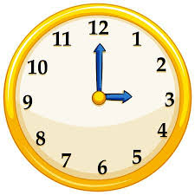  Have a look what time it is when you eat your breakfast, eat your lunch and what time you go to bed. Could you write a daily report of what you do at different times of the day? | Writing  Read your favourite story book. Can you write a blurb about the story? A blurb is a short piece of writing which tells you all about what happens in the story.  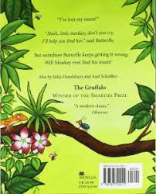  Remember - You always find the blurb on the back of the book! | 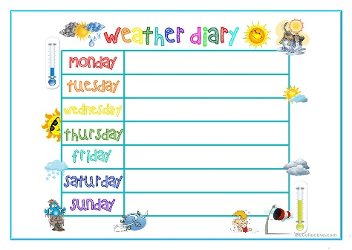  Weather  We are now in the season of Spring and you will notice that the weather is becoming warmer and the sun in shining a lot more. Could you write a weekly weather diary all about what the weather is like? Include pictures of the plants and the trees (make sure to use adjectives to describe them ). | Counting in 2s  Draw around your family members shoes or feet. Can you use 2p coins to measure the size of each person’s feet in your house? Who has the cheapest feet? Who’s are the most expensive?  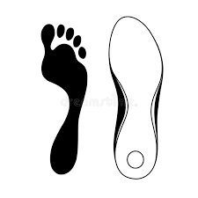
Our Local Area  Our topic at school would have been all about our local area. Can you have a walk around your local area and walk your usual route to school? Create a map of what your local area looks like and draw the route you walk to school.  Make sure to include roads, houses, street names and parks! | P.E.  I know you are all amazing at Cosmic Kids Yoga. Can you watch some of the videos on YouTube? Can you create your own Yoga poses or even your own Yoga routine?  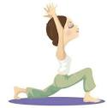 | One More and One Less  Can you find one more and one less of the following numbers?  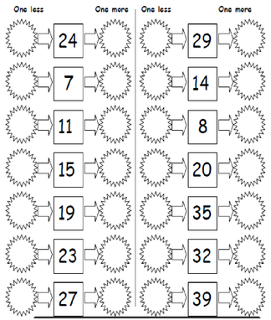 | Researching  What is your favourite animal? Can you use a book or the internet to find out all about that animal? Can you create a fact file about the animal and make sure to include three interesting facts!  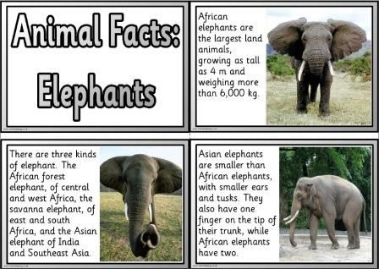  Make sure to draw a picture of your animal
Counting  Can you practise counting in 2s, 5s and 10s to 100? If you want to make it extra tricky why not try and do it backwards.  Log in to timestables rockstars to see how quick you can do your timestables.  www.ttrockstars.com  Your Timestables Rockstars log in is your name and the first letter of your surname.  E.g.  Username: toms (Tom Smith)  Password: cups | Quick Maths  Can you use these numbers to create some addition and subtraction questions…  3, 5, 7, 8, 11  E.g. 5 + 7 = __  11 – 3 = __  Try to create as many questions as possible! | Phonics  Can you remember all of the different spellings of /ie/?  The spellings we have practised are:  /ie/ /igh/ /y/ /i_e/  I have accidentally jumbled up the words. Can you sort these words into the correct spellings? Then can you write some sentences using the words?  tie high cry shine fly kite pie night try bike quiet slide flight | Get Trying!  Can you try to tie your own shoelaces? Practise using one of your adults if you need to. Watch this video on Youtube to help:  https://www.youtube.com/watch?v=VA4AACzlhe8  Next, how quickly can you get yourself dressed on a morning? We always have a countdown after P.E., do you think you can be the quickest at getting ready when we get back to school?  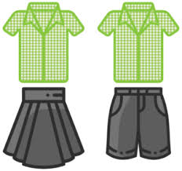
Everyday Materials  Can you collect some items from around your home? Keep your cereal box and yoghurt pots etc.  Test in your sink or bath tub which materials are waterproof. Which material would be best to build a boat with?  Could you design and sketch your boat?  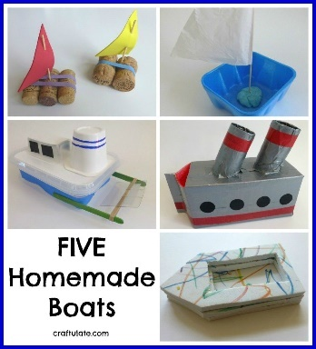 | Stay Active!  Get your stopwatch at the ready!  Time how long it takes you to do:  20 star jumps  20 high knees  20 heel kicks  20 tuck jumps  20 sit ups  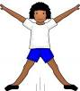  I did it in 2 minutes 27 seconds, can you beat my time? | Handwriting Time!  Time to practise your handwriting.  Practise writing the following letters:  a a a a a a  e e e e e e  o o o o o o  Remember all of your letters must start on the line and leave a finger space between each letter.  Can you make up a silly sentence using the letters?  An elephant has a long orange tail. | Stay safe and be Kind!

