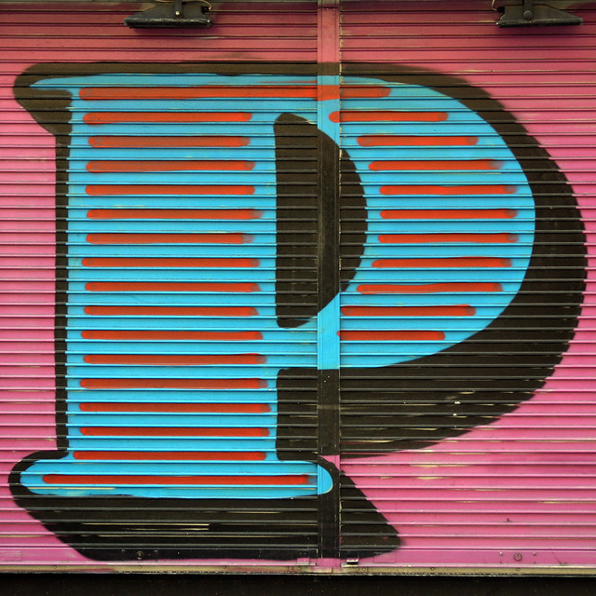





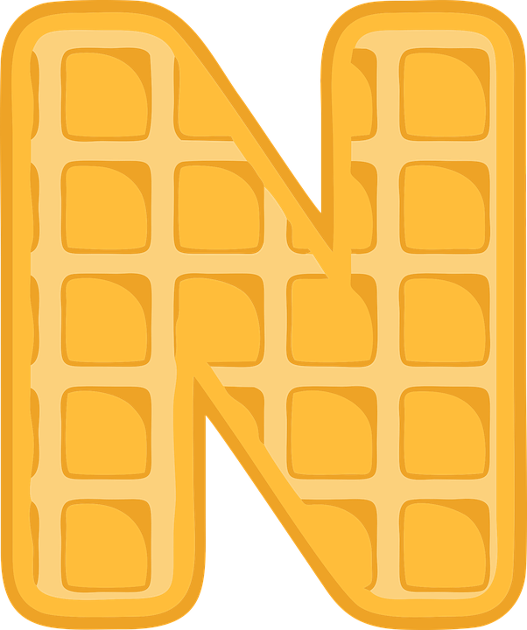

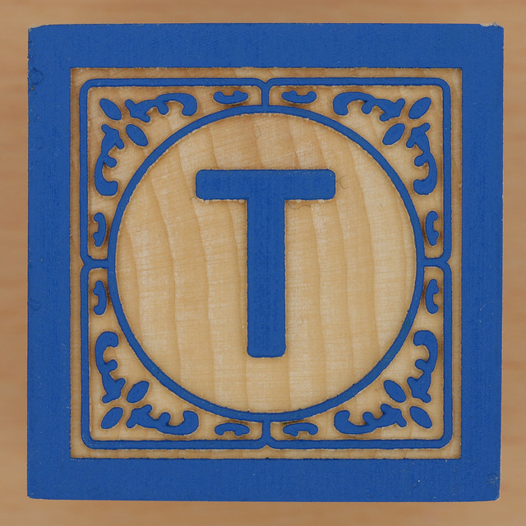

All around us!

**Things to look on your daily walk**

Look for different shapes, numbers and letters on road signs, houses, pavements and drain covers. Look at the markings on the roads.

Can you find any posters, print on taxis, print on shop fronts?

Talk about the meaning these examples of print carry.

Learn the names of the roads in your neighbourhood.

Learn your own address and postcode.

[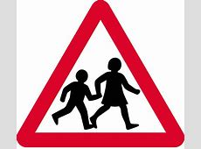](https://assets.wired.com/photos/w_1200/wp-content/uploads/2015/10/1965-Sign-for-Children.jpg) [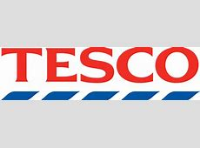](https://upload.wikimedia.org/wikipedia/en/thumb/b/b0/Tesco_Logo.svg/1280px-Tesco_Logo.svg.png)

**Activities to do in the home**

Look at the print on coins – add up the coins, play shops.

Search for numbers around the house. Can you find every digit from 0-9?

Search for 3D shapes – which 2D shapes are they made up from? Can you sort them into sets?

Look at the print on packaging (cereal boxes, tins, bottles)

Make your own name card and decorate it.

Make up number plates for family cars.

**Shape vocabulary**

cube cuboid cone cylinder sphere

circle triangle square oblong

curved straight edges corners faces

**Kandinsky**

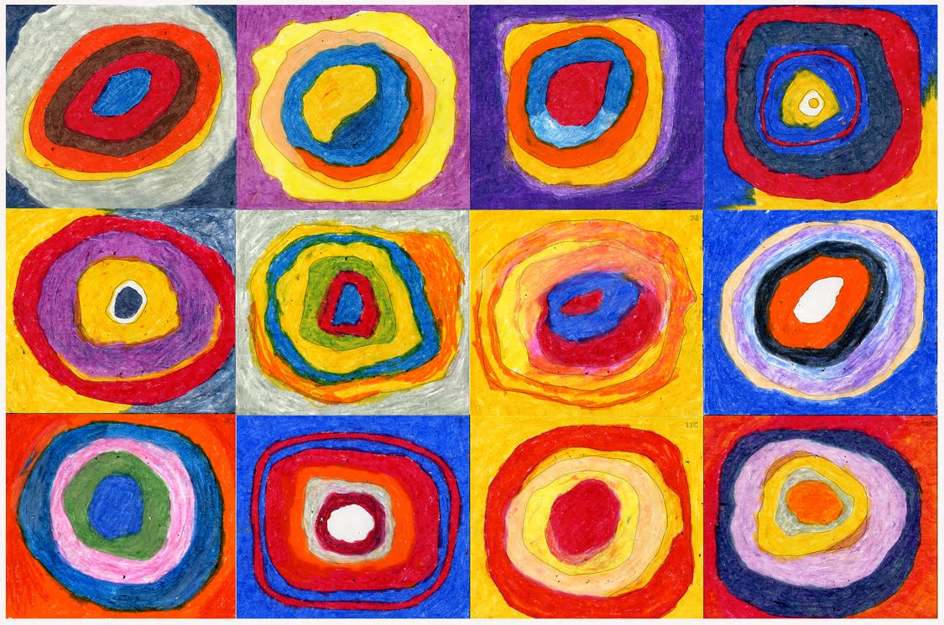[](http://telegraph.co.uk/content/dam/art/2015-07/july20/Kandinsky_3139290b.jpg?imwidth=450)

Look at the work of Kandinsky. What can you see? Can you create your own art work? You could use paint with sponges or free hand, cut up paper into shapes and stick them, use playdough and cutters, or draw around shapes using things you find at home – then add colour. Have fun!!