Creative Activities

Design a pair of socks for yourself, for your family or for your teacher.

What patterns might you put on them – stripy, rainbow, spots, dinosaurs, flowers etc.

If you have buttons, cotton and a needle you could make a sock puppet.

Use a sock shape to draw other things.

Maths Activities

Count them, sort them by colour, by size, by owner, estimate how many you can pick up in one hand, compare who has more or fewer.

Measure them – and order them from shortest to longest.

How many socks can you peg on a washing line in 1 minute, challenge other members of your family.

Match them back together.

Physical

Make a ball out of socks

Practise throwing and catching by yourself, or with a member of your family. How many times can you throw and catching without dropping it?

Can you throw it to a target, so it lands in a bucket, washing up bowl or hula hoop?

Hide the sock – give clues to find it.

Philosophy for Children

You Choose! – from the selection of socks which would you choose as your favourite? Why?

Which socks would you pick for other people in your family or for your friends at school?

Literacy Ideas

Label your socks with describing words – soft, long, fluffy, tiny (use your phonic knowledge to spell the words.)

Write a poster for your “missing sock”

Socks Challenge

You will need as many socks as you can find in your home.

[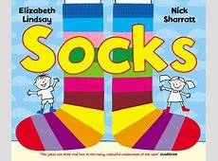](http://images.foyles.co.uk/xlarge/books/img/0/5/5/9780552572217.jpg)

[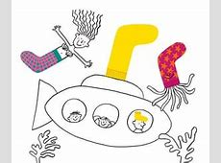](https://i.guim.co.uk/img/static/sys-images/Guardian/Pix/pictures/2012/3/28/1332935672792/Easter-Childrens-Books----002.jpg?width=300&quality=85&auto=format&fit=max&s=287ab6daf0da2c4bd434c37dc87f845f)[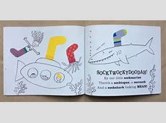](https://letsreadinenglish.files.wordpress.com/2016/01/image57.jpeg?w=456&h=223)

[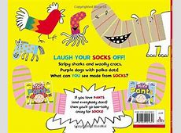](http://ecx.images-amazon.com/images/I/51a5QBzDbLL.jpg)

[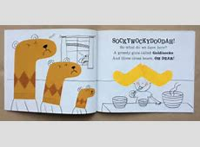](https://letsreadinenglish.files.wordpress.com/2016/01/image53.jpeg?w=420&h=203)