Home Activity Grid
As well as reading and using Bedrock and Times Table Rock Stars here are some activities you might want to try at home based on your Spring 2 Topic: Rivers
Write a story featuring a river. Make sure it has exciting events and language to keep the reader engaged throughout.  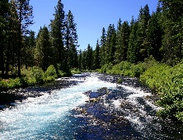  You might want to make it a warning story or a beat the monster story! | Research statistics of a range of different rivers (e.g. length, number of countries it travels through, maximum width) and make into a set of top trumps cards. | Research the plants and animals that live in and near rivers. Create food chains or food webs. Remember to use key words like: producers, consumers, herbivores.  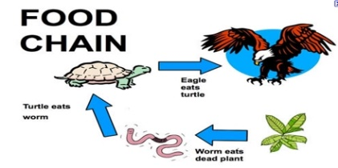
Research the recent flooding in the UK? Which rivers flooded? Can you find them on a map? Use Google Earth to find them. What is the landscape like? Can you spot any human or physical features? | Use a photograph of a river to inspire a collage. Choose one medium for the collage (e.g. tissue, fabric, wool). | Design a costume for a dancer performing in a river-themed dance. Draw it. You could even collect fabrics that you could use or make part of the costume.
Research one river in detail and present the information in a poster or report. | Make a list of ways that water is essential to people, plants and animals. What would happen if there was no more rain? | Research a water-borne disease (such as cholera) and present your information in a poster or leaflet.
Make a model of a famous bridge.  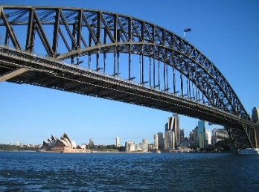 | Find out the length of at least 10 different rivers and order them. | Write a song or poem about wasting water and persuading people to be more careful with their water usage.  This Photo by Unknown Author is licensed under CC BY-SA-NC

