Christmas Child Shoe Box Gift Suggestions
Include items that children will immediately embrace such as dolls or stuffed toys (with CE label), toy trucks, harmonica, yo-yo, skipping rope, ball, small puzzles etc. | 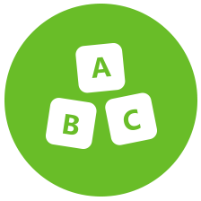 Toys
Pens, pencils & sharpeners, crayons or felt pens, stamps & ink pad sets, writing pads or notebooks & paper, solar calculators, colouring & picture books etc. | School Supplies
Toothbrush and toothpaste, bars of wrapped soap, comb or hairbrush, flannel. | 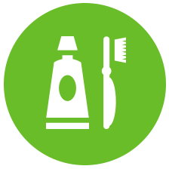 Hygiene Items
Hat, cap, gloves or scarf, sunglasses, hair accessories, jewellery set, wind up torch, wrapped sweets (best-before-date must be at least March of the following year). | Other Items
Please do not pack  Chocolate or food, liquids or lotions including bubbles, medicines or knitted stuffed toys. Sharp objects, anything glass or fragile which might break, packs of cards | Please don’t send

We know you have been very generous with the Children in Need donations and the Poppy Appeal and hope that if some children from each class can bring one item to put in the Christmas Child shoe box we can send some boxes to this excellent appeal as part of our Refugee Week learning. Middlesbrough has become a City of Sanctuary and Breckon Hill has applied to become a School of Sanctuary. This means that the children, staff and parents are recognised for the work we have always done welcoming people from all over the world. Please check our website for any further information.
www.breckonhillprimary.co.uk

